

IR CAMERA

Document Title: VIRGO Module SCA-35 Test Report

Document Number: VIS-TRE-ATC-06032-1035

Issue: Draft 0.1

Date: 19 November 2004

Document  Prepared By: | Naidu Bezawada  Electronics Engineer | Signature and Date:
Document  Approved By: | Mel Strachan  ATC Project Manager | Signature and Date:
Document Reviewed By: | Gavin Dalton  IR Camera Project Scientist | Signature  And Date:
Document  Reviewed By: | Martin Caldwell  IR Camera Systems Engineer | Signature and Date:
Document  Released By: | Kim Ward  IR Camera Project Manager | Signatures and Date:

The information contained in this document is strictly confidential and is intended for the addressee only. The unauthorised use, disclosure, copying, alteration or distribution of this document is strictly prohibited and may be unlawful.

Change Record

Issue | Date | Section(s) Affected | Description of Change/Change Request Reference/Remarks
Draft 0.1 | 19/11/04 | All | New document

TABLE OF CONTENTS
Change Record 2
1. PERFORMANCE SUMMARY 4
2. DC Uniformity 5
3. System gain and conversion gain 7
4. Read noise 12
5. Dark generation 15
6. Quantum Efficiency 17
7. Persistence 23
8. Inoperable Pixels 26
9. Temporal Stability 27
10. Cosmetics 29
11. Read back voltages 31
12. Conclusion 33

PERFORMANCE SUMMARY
Module Number # VM301-35-SCA
Operating temperature 72K
Pixel rate = 294 kHz
Outputs = 16
Frame readout time = 1.001s

Detector bias:
VRstUc = 0.0V
VnUc = 0.5V (0.7V)
VDetCom = 0.5V (0.7V)

Mean DC level = 3.285V @ 0.5V
3.299V @ 0.7V

Detector transimpedance = 4.387µV/e⁻ (20 – 70% of full well)
(0.5V) = 4.634µV/e⁻ (up to ~ 20% of full well)

Dark generation = 0.80e⁻/s/pixel (mean) @0.5V detector bias
Operability = 97.67% (>0, < 8e⁻/s)

Read noise
Temporal = 18.7e⁻ (rms)
Pixel-to-pixel = 21.4e⁻ (rms)

Full well (ke⁻) = 87ke⁻ (@ 0.5V)
120ke⁻ (@ 0.7V)

Non-linearity = 3.5% @0.5V, 5.2% @ 0.7V

QE* | Mean (%) | Sigma | Non-Uniformity  (sigma / mean)
J-Band | 92.4 | 4.5 | 4.9%
H-Band | 96.3 | 4.6 | 4.8%
K-Band | 90.7 | 3.9 | 4.3%
* - Includes only operable pixels

Persistence signal = 7.8e⁻

Total Pixel operability = 97.3%

DC Uniformity
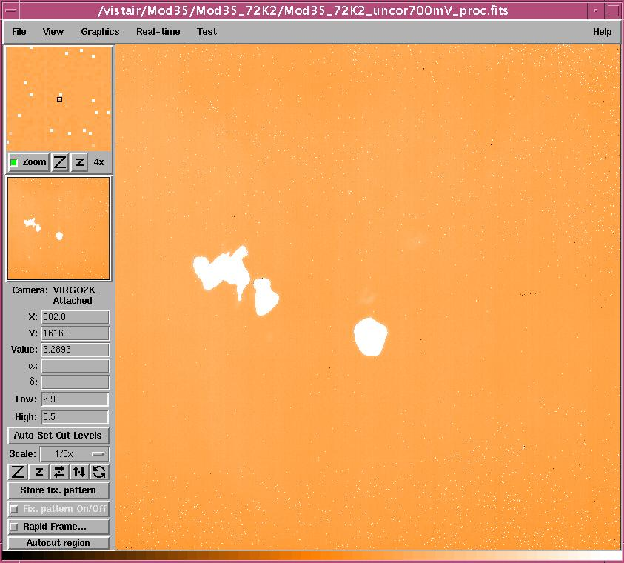

DC Uniformity (0.7V detector bias)

Mean DC @0.5V = 3.285V, Sigma = 0.039V

Mean DC @0.7V = 3.299V, Sigma = 0.064V

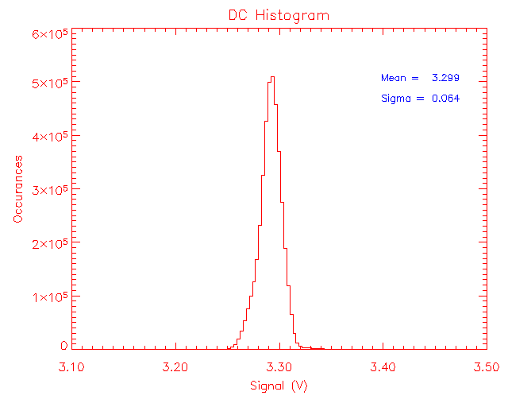
DC Uniformity (Histogram)

Mean DC = 3.299V, Sigma = 0.064V

System gain and conversion gain

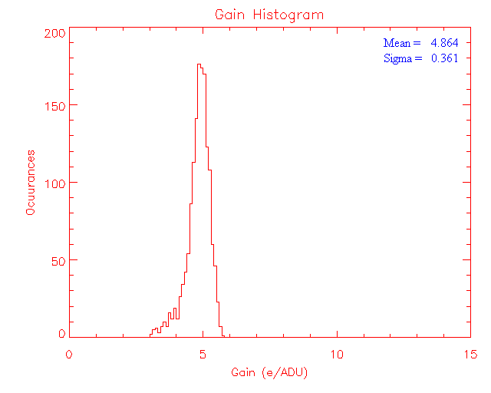

System gain (20 -70% of full well) – 0.7V bias

System gain @ 0.5V bias = 5.197e⁻/ADU
System gain @ 0.7V bias = 4.864e⁻/ADU

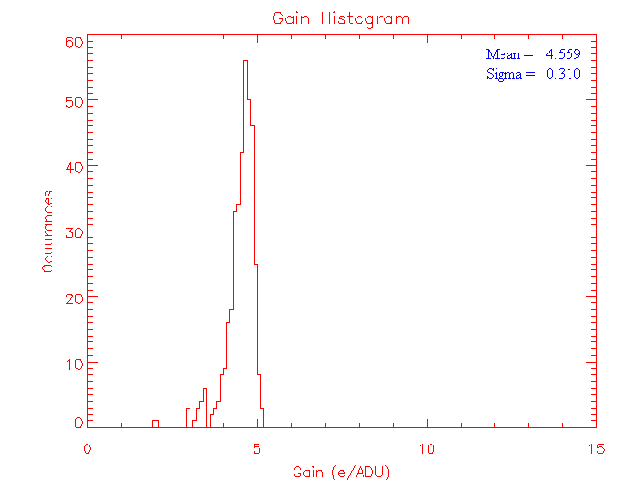
System gain (up to ~20% full well) – 0.7V bias

System gain @ 0.5V bias = 4.921e⁻/ADU
System gain @ 0.7V bias = 4.559e⁻/ADU

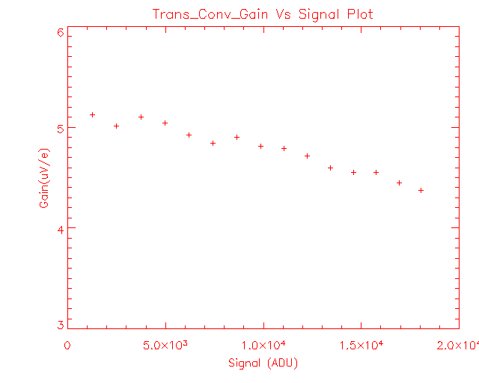
Transimpedance conversion gain vs. signal level (0.7V)

Transimpedance conversion gain @ 0.5V bias = 4.387µV/e⁻ (20 – 70% full well)
= 4.634µV/e⁻ (up to ~20% full well)

Transimpedance conversion gain @ 0.7V bias = 4.688µV/e⁻ (20 – 70% full well)
= 5.0µV/e⁻ (up to ~20% full well)

Linearity and full well

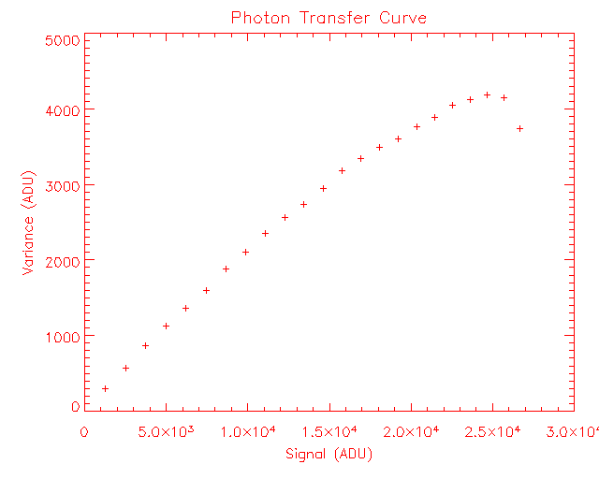
Photon transfer – full well obtained from noise roll-over in the plot (0.7V)

Full well @ 0.5V bias = 87ke⁻

Full well @ 0.7V bias = 120ke⁻

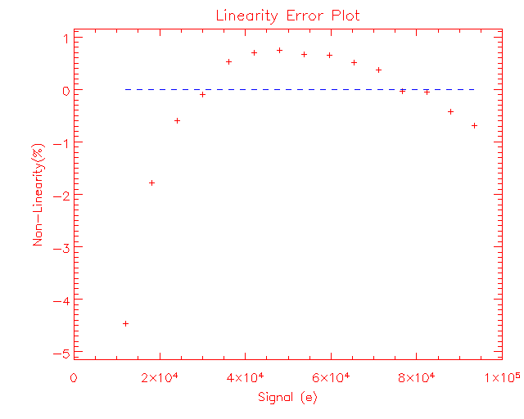

Non-linearity plot (0.7V)

Estimated from 10 – 80% of saturation levels

Non-linearity = ~ 3.5% (0.5V bias)
= ~ 5.2% (0.7V bias)

Read noise

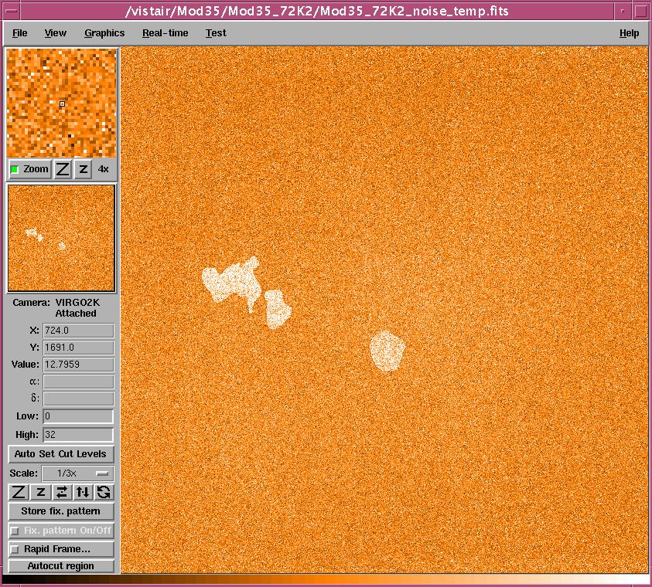

Read noise bitmap (temporal)

Estimated from 10 CDS frames (0.7V)
The array mean read noise (temporal) is 17.3e⁻ (rms).
Number of pixels >32e⁻ noise is 1.28%.

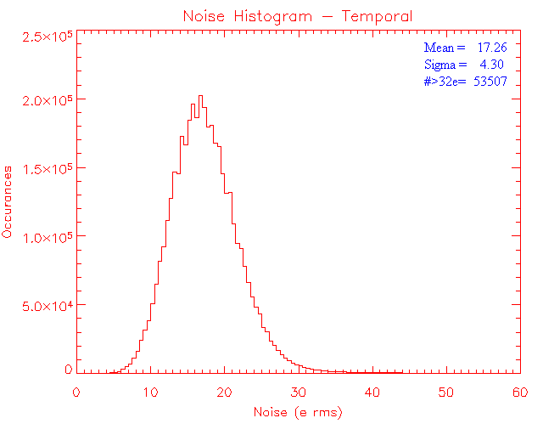
Read noise histogram (temporal)
Obtained from 10 CDS frames with minimum detector integration time

Histogram shows the array mean excluding the pixels >32e⁻
The array mean for all pixels in the frame is 18.7e⁻.

1.28% pixels show read noise >32e.

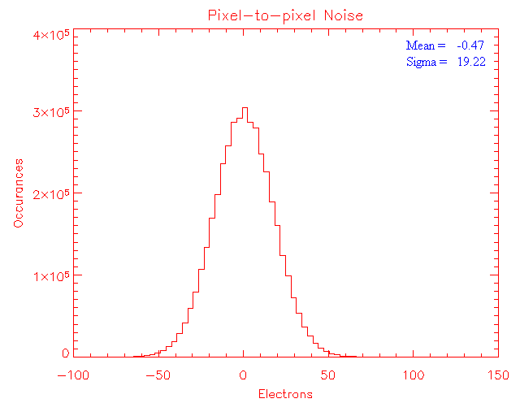
Pixel-to-pixel read noise (excluding pixels with dark > 8e/s)

Obtained from two subsequent dark frames with minimum detector integration time

Closely agrees with the temporal noise

Read noise measured the 1st output = 18.9e⁻.

Dark generation

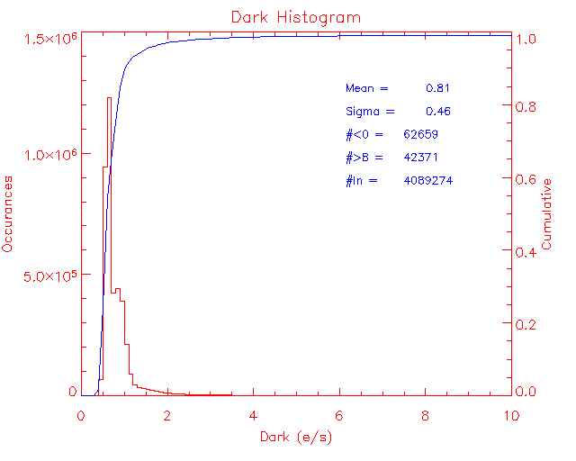
Dark generation (@ 0.7V detector bias)

Measured after a settling time of ~3hrs (i.e. after adjusting any detector bias voltage)

An average of 10 CDS frames (each with 240 sec. integration time) is used to estimate the mean dark generation. Mean dark generation for the full frame excluding pixels with 0 < dark generation > 8e⁻/sec is estimated as 0.81 e⁻/sec/pixel (σ = 0.46). The pixels in limits are ~97.5%.

Mean dark @0.5V bias = 0.80e⁻/s/pix with pixels in limits =97.7 % (with VnUc = 0.7V)
Mean dark @0.7V bias = 0.81e⁻/s/pix with pixels in limits =97.5 % (with VnUc = 0.7V)

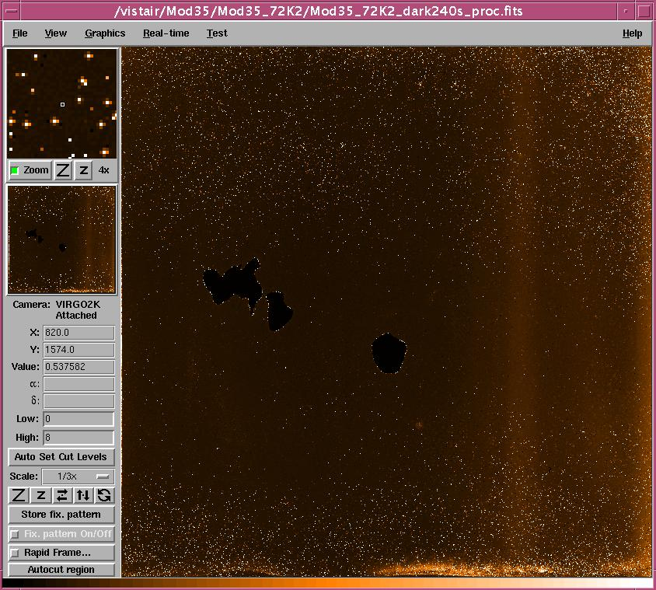

Dark generation bitmap (0.7V detector bias) – mean dark = 0.81e⁻/s/pix. (0 < dark <8)

Dark from a region relatively free from hot pixels (in the centre) measured as 0.61e⁻/s/pix.

Quantum Efficiency
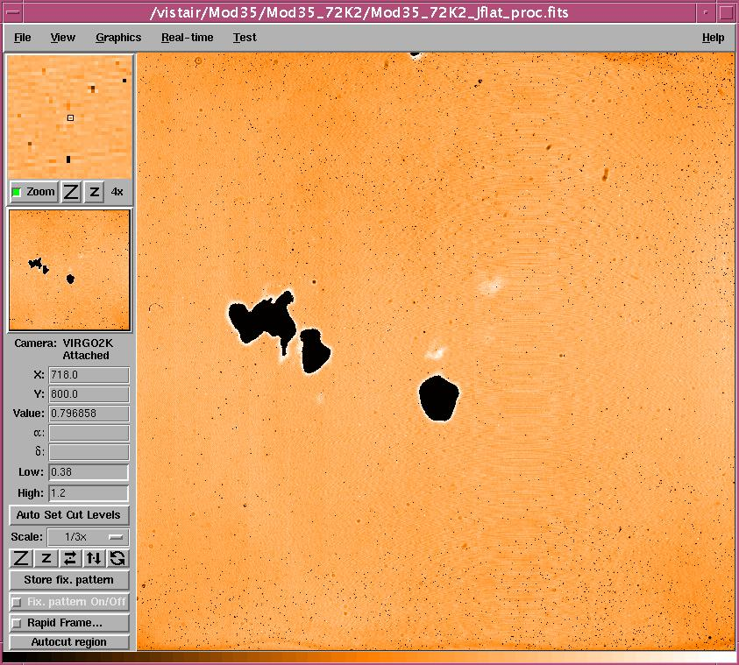

QE bitmap (J-band)
Image stretched between 0.38 and 1.20 limits

Mean = 0.924
Sigma = 0.045

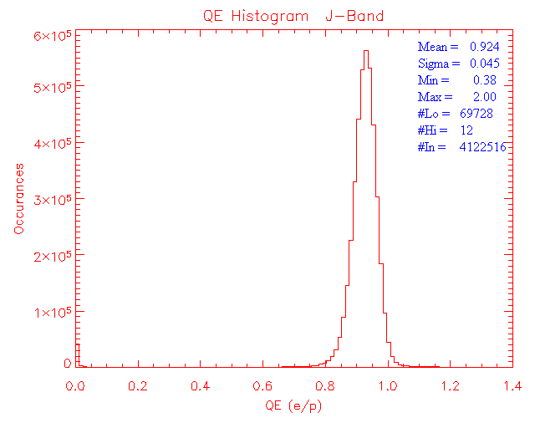
QE histogram (J-band)

Mean and sigma are obtained from operable pixels

Non-uniformity = 4.9% (for pixels in limits)

Operability = 98.34%

Blackbody temperature: low = 350ºC (9.83E8 ph/cm²/s)
High = 380ºC (2.26E9 ph/cm²/s)

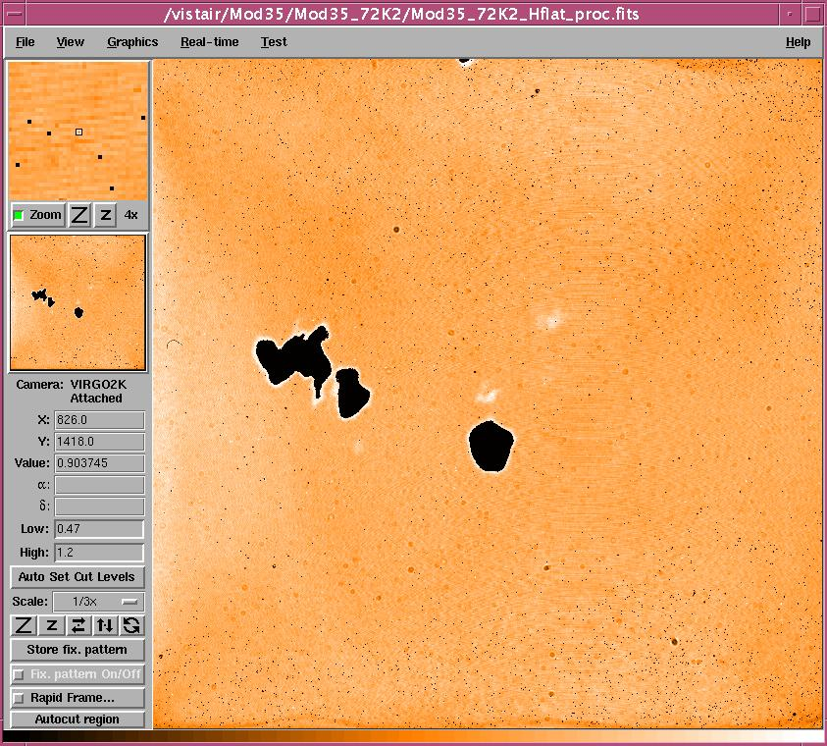

QE bitmap (H-band)

Mean = 0.963
Sigma = 0.046

Image stretched between 0.47 and 1.2 limits

Mean and sigma are obtained from operable pixels

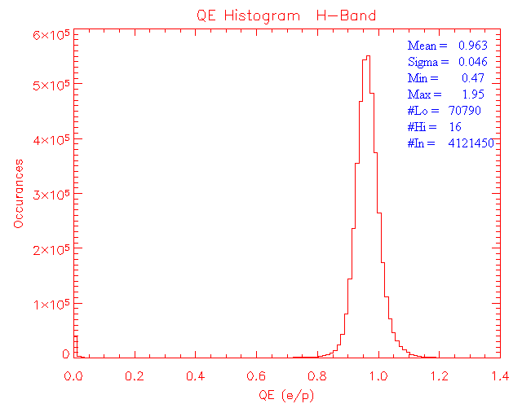
QE histogram (H-band)

Mean and sigma are obtained from operable pixels

Non-uniformity = 4.8% (for pixels in limits)

Operability = 98.31%

Blackbody temperature: low = 220ºC (1.25E9 ph/cm²/s)
High = 250ºC (3.38E9 ph/cm²/s)

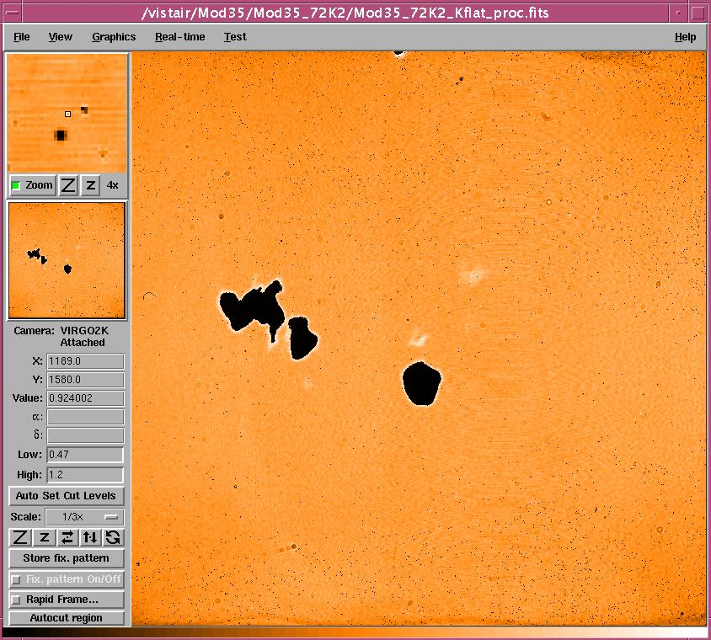

QE bitmap in K-band
Mean = 0.907
Sigma = 0.039

Image stretched between 0.47 and 1.20 limits

Mean and sigma are obtained from operable pixels

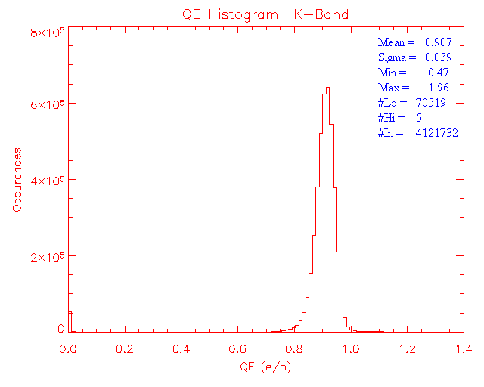
QE histogram (K-band)

Mean and sigma are obtained from operable pixels

Non-uniformity = 4.3% (for pixels in limits)

Operability = 98.32%

Blackbody temperature: low = 120ºC (1.36E9 ph/cm²/s)
High = 150ºC (4.31E9 ph/cm²/s)

Persistence
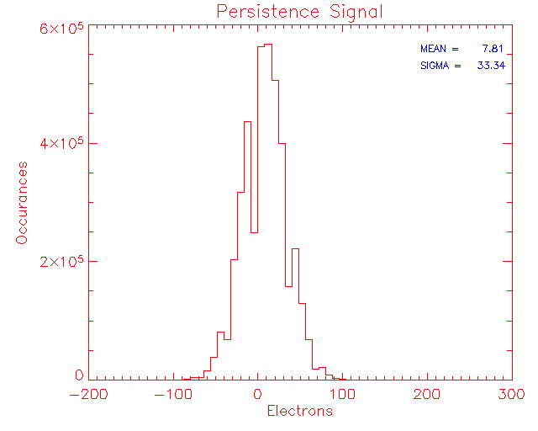
Figure shows the histogram of the persistence signal in a 10s dark after a minute after saturation.

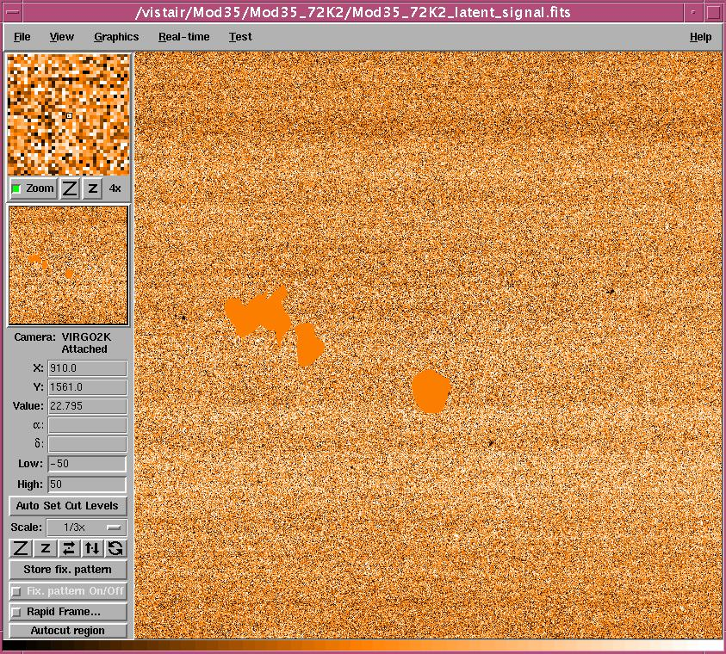

Persistence signal in a 10s dark

Figure shows the persistence signal in a 10s dark after 1 minute after saturation with ~200ke⁻ fluence. The detector is continuously read every 10s after saturation and the persistence decay is obtained.

Persistence signal decay

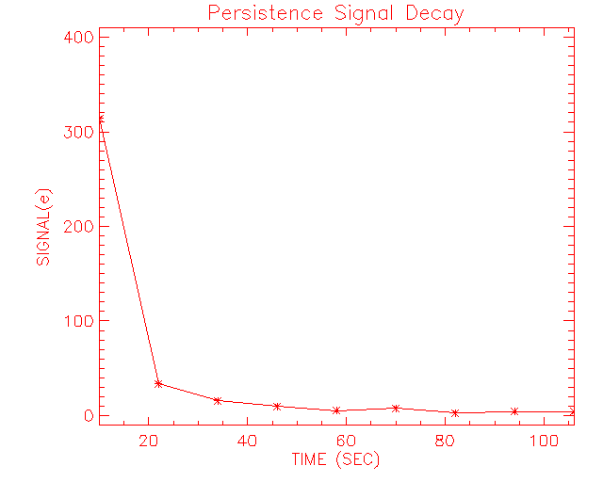
The array mean is 7.8e⁻.

Inoperable Pixels

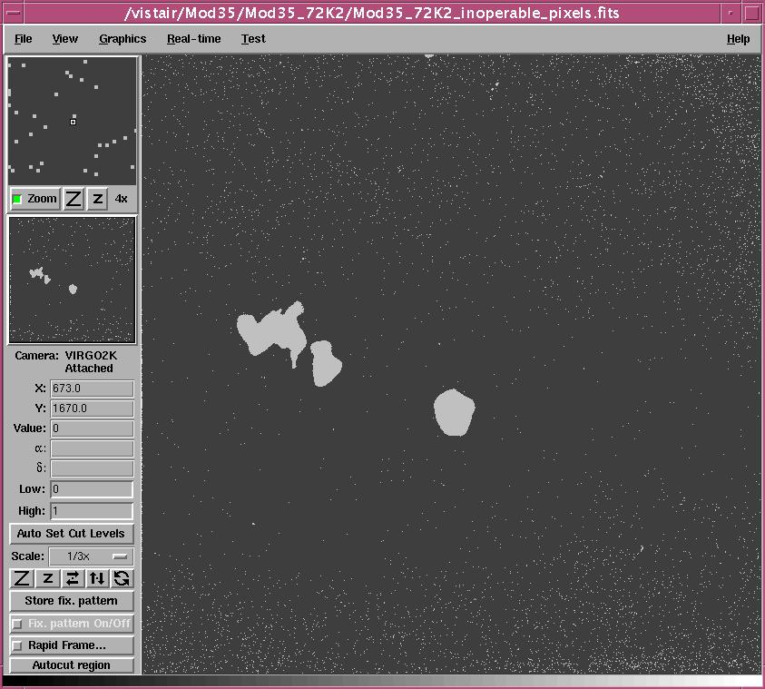

Inoperable pixels bitmap (white pixels)

Total inoperable pixels = ~2.70%

Obtained from dark operability (0 < dark <8e/s), and QE operability in J, H and K bands

About 1.6% of these are in the large area defects
Open pixels = 1230

Temporal Stability
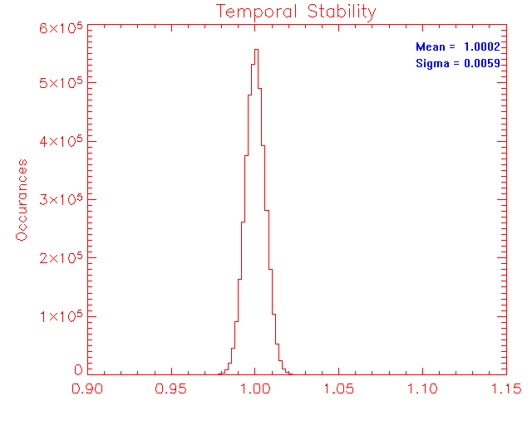
Temporal stability (K-band)

Ratio of two identical flats (50% full well) obtained 5 days apart

Flats are divided by one another and a histogram of the resulted frame is shown above. Inoperable pixels (see bitmap above) have been excluded from the measurement.

Temporal stability in J band = 0.73% (~ 50% full well, one day apart)

Temporal stability in H band = 0.59% (~ 50% full well, one day apart)

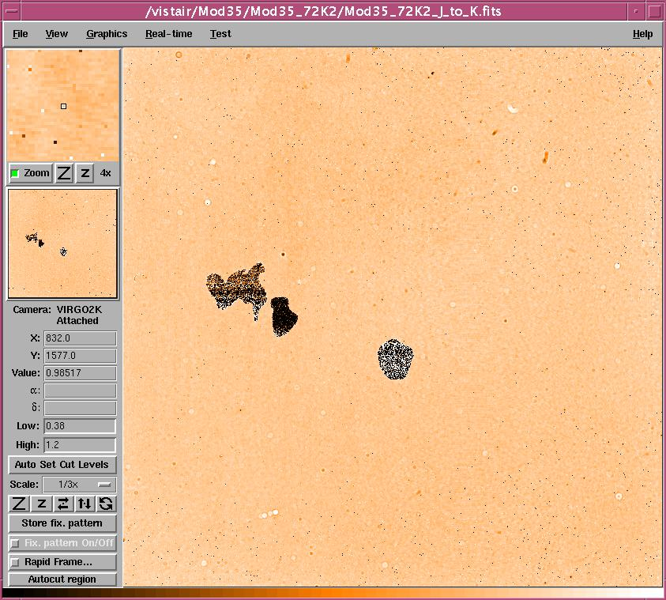

Ratio of J to K flat

Cosmetics

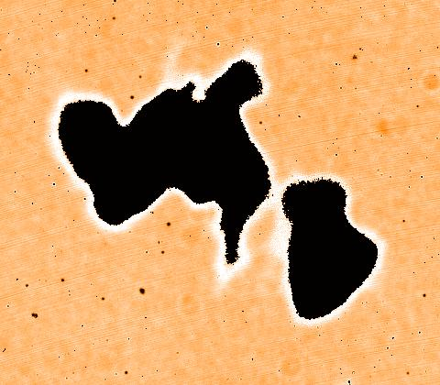

Large area defects in a 480 x 420 section

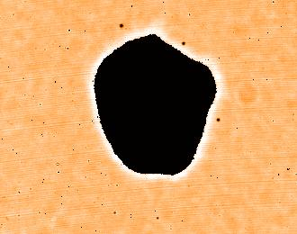
Large area defect in a 330 x 260 section

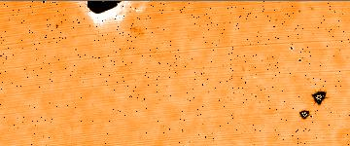
Chip-off on top and two small cluster defects in a 360 x 150 section

AR coating is fine

Read back voltages
Warm (before thermal cycle)
DC | Name | Value1(V) | Value2(V) | Current(mA)
DC1 | vhiReset | 3.999 | 3.979 | 0.20
DC2 | vloReset | 0.005 | 0.005 | -
DC3 | vIdle | -2.363 | -2.344 | 0.19
DC4 | vSlew | -3.999 | -3.970 | 0.29
DC5 | vhiRowEn | 5.000 | 4.966 | 0.34
DC6 | vloRowEn | 0.996 | 1.025 | 0.29
DC7 | vCas | 2.998 | 2.993 | -
DC8 | vpD | 3.999 | 3.970 | 0.29
DC9 | vrstUc | 0.005 | 0.005 | -
DC10 | vpUc | 3.496 | 3.418 | 0.78
DC11 | vnUc | 0.601 | 0.654 | 0.53
DC12 | vnOut | 2.197 | 2.388 | 1.91
DC13 | vdetCom | 0.698 | 0.698 | -
DC14 | vpOut | 9.741 | 9.546 | 1.95
DC15 | vBiasRef | 3.452 | 3.447 | -

Read back voltages – Cold
DC | Name | Value1(V) | Value2(V) | Current(mA)
DC1 | vhiReset | 3.999 | 3.989 | 0.10
DC2 | vloReset | 0.005 | 0.005 | -
DC3 | vIdle | -2.363 | -2.354 | -
DC4 | vSlew | -3.999 | -3.984 | 0.15
DC5 | vhiRowEn | 5.005 | 5.000 | -
DC6 | vloRowEn | 1.001 | 0.996 | -
DC7 | vCas | 2.998 | 2.993 | -
DC8 | vpD | 3.999 | 3.975 | 0.24
DC9 | vrstUc | 0.005 | 0.005 | -
DC10 | vpUc | 3.496 | 3.428 | 0.68
DC11 | vnUc | 0.601 | 0.654 | 0.53
DC12 | vnOut | 2.197 | 2.378 | 1.81
DC13 | vdetCom | 0.698 | 0.698 | -
DC14 | vpOut | 9.746 | 9.556 | 1.90
DC15 | vBiasRef | 3.452 | 3.452 | -

Read back voltages – warm (after thermal cycle)
DC | Name | Value1(V) | Value2(V) | Current(mA)
DC1 | vhiReset | 3.994 | 3.975 | 0.19
DC2 | vloReset | 0.005 | 0.005 | -
DC3 | vIdle | -2.363 | -2.344 | 0.19
DC4 | vSlew | -3.999 | -3.970 | 0.29
DC5 | vhiRowEn | 5.000 | 4.966 | 0.34
DC6 | vloRowEn | 0.996 | 1.025 | 0.29
DC7 | vCas | 2.998 | 2.993 | -
DC8 | vpD | 3.999 | 3.965 | 0.34
DC9 | vrstUc | 0.005 | 0.005 | -
DC10 | vpUc | 3.491 | 3.418 | 0.73
DC11 | vnUc | 0.601 | 0.654 | 0.53
DC12 | vnOut | 2.197 | 2.388 | 1.91
DC13 | vdetCom | 0.698 | 0.698 | -
DC14 | vpOut | 9.741 | 9.541 | 2.00
DC15 | vBiasRef | 3.452 | 3.447 | -

Conclusion
Module#35 shows very good performance except for the three large area defects. The detector has overall operability of 97.3%. Transimpedance conversion gain of 4.39µV/e⁻ at 0.5V is measured which is slightly different from the RVS value (4.78µV/e⁻). The conversion gain is estimated both at 0.5V and 0.7V bias and also estimated for low and high signal levels. The low level conversion gains are applied for dark, read noise and persistence. The high signal conversion gain is applied for estimating the full well capacity. Full well of ~87ke⁻ is obtained with 0.5V bias with non-linearity of 3.5%. Full well of ~120ke⁻ is obtained at 0.7V detector bias with non-linearity ~5.2%. The high transimpedance conversion gain corresponds to a less diode junction capacitance and thus low well capacity.
A mean dark generation of 0.81e⁻/s/pix is measured for the array at 0.7V (0.80e⁻/s/pix @ 0.5V) after about of 3 hours settling time. Dark pixel operability is ~97.5% with pixels in limits (0 < dark < 8e⁻/s/pix).
High QE’s over 90% have been measured in all bands. RVS reported QEs in J (61%), H (80.0%) and K (79%) largely differ from ATC measurements. A note in the RVS data pack says that they had assumed the blackbody emissivity as 98% (different from previous modules?). That could explain some of these large differences.
Temporal read noise of ~17.3e⁻ (rms) is obtained for the entire array while the pixel-to-pixel noise is ~19.8e⁻. RVS have reported the pixel-to-pixel noise in one output (channel-1) as 22.1e⁻. ATC measured the pixel-to-pixel noise in the same output as 20.5e⁻.
Persistence signal decays below 32e⁻ in about 25s. The array mean persistence signal after a minute after saturation is 7.8e⁻.
This detector shows three large area defects (pixels are non-responsive) which are about 1.6% of total pixels. There is a fence of hot and high responsive pixels around each of these defects spreading few (~6) pixels.
Except for the large area defects, this detector shows very good performance and meets the specifications. High QEs with good uniformity in all bands, low dark generation, low persistence, and low noise make this detector a good science detector.

---oOo---

