

IR CAMERA

Document Title: Read Reset Readout Mode with VIRGO Detectors

Document Number: VIS-TRE-ATC-06032-xxxx

Issue: Draft 0.1

Date: 27 September 2006

Document  Prepared By: | Naidu Bezawada  Electronics Engineer | Signature and Date:
Document  Approved By: | Mel Strachan  ATC Project Manager | Signature and Date:
Document Reviewed By: | Gavin Dalton  IR Camera Project Scientist | Signature  And Date:
Document  Reviewed By: | Martin Caldwell  IR Camera Systems Engineer | Signature and Date:
Document  Released By: | Kim Ward  IR Camera Project Manager | Signatures and Date:

The information contained in this document is strictly confidential and is intended for the addressee only. The unauthorised use, disclosure, copying, alteration or distribution of this document is strictly prohibited and may be unlawful.

Change Record

Issue | Date | Section(s) Affected | Description of Change/Change Request Reference/Remarks
Draft 0.1 | 26-09-06 | All | New document

TABLE OF CONTENTS
Change Record 2
1 Introduction 4
2 Reset and Read Modes 4
3 Dark Frames 5
4 Light Frames 7
5 Read Noise 9
6 DC Offset 10
7 Conclusions 11

Introduction

A new readout mode called ‘READRESET’ has been implemented in the test IRACE at ATC and tested with VIRGO detector module#31. This document describes the implementation of the new READRESET readout mode and compares the performance of the detector noise and sensitivity with normal mode.

Reset and Read Modes
In the row reset mode, after all the pixels in a row have been accessed, the row is reset prior to advancing to the next row. Presently, READ and RESET operations are implemented as follows:

RESET Operation: Start with reset enabled and access every pixel in the row without digitising. The row gets reset at the end of the row before advancing to next row. This is repeated for all the rows in order to reset entire array.

READ Operation: Start with reset disabled and access every pixel in the row and digitise. The row doesn't get reset at the end of the row before advancing to next row. This is repeated for all the rows in order to read full frame.

Presently a CDS frame is obtained from executing the following sequence (called as ‘Normal CDS sequence’)

LOOP
RESET
READ
EXPOSE
READ
END

The first READ is subtracted from the second READ to generate a CDS frame. With this sequence, it takes 3s to obtain a CDS frame with minimum detector integration time.

A new readout mode which simultaneously resets the detector is implemented as follows:

READRESET operation: Start with reset enabled and access every pixel in the row and digitise. The row gets reset at the end of the row before advancing to the next row. This is repeated for all the rows in order to read and reset simultaneously the entire array.

A CDS frame is obtained with the READRESET readout mode by executing the following sequence (called ‘New CDS sequence’).

RESET
LOOP
READ
EXPOSE
READRESET
END

With this sequence, it takes 2s to obtain a CDS frame with minimum detector integration time.

Dark Frames

With the new CDS sequence, a simple CDS frames showed fixed pattern noise. The fixed pattern corresponds to defects along the rows which have defects. There is also a slight fixed pattern corresponding to the readout boundaries as seen the Figure 1. For comparison, a similar dark frame obtained from the normal CDS sequence is shown in Figure 2. The fixed pattern seen with the new CDS sequence subtracts out from two identical dark frames (Figure3).
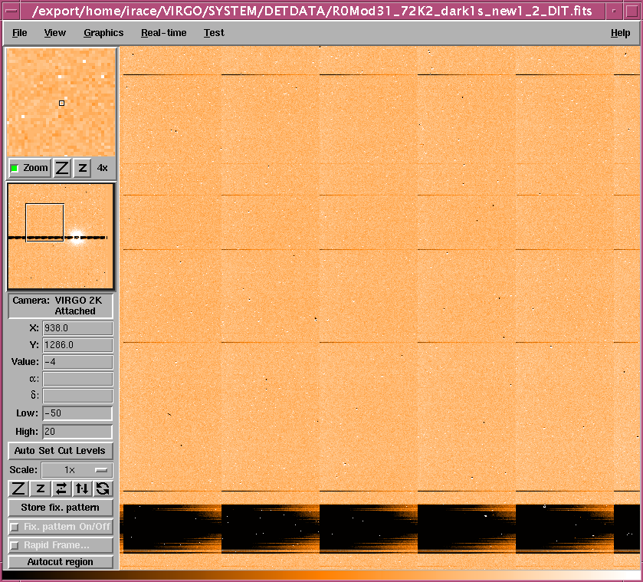
Figure 1: A region of the full frame showing fixed pattern corresponding to defects along the rows (with new CDS sequence). Readout boundaries can also be seen.
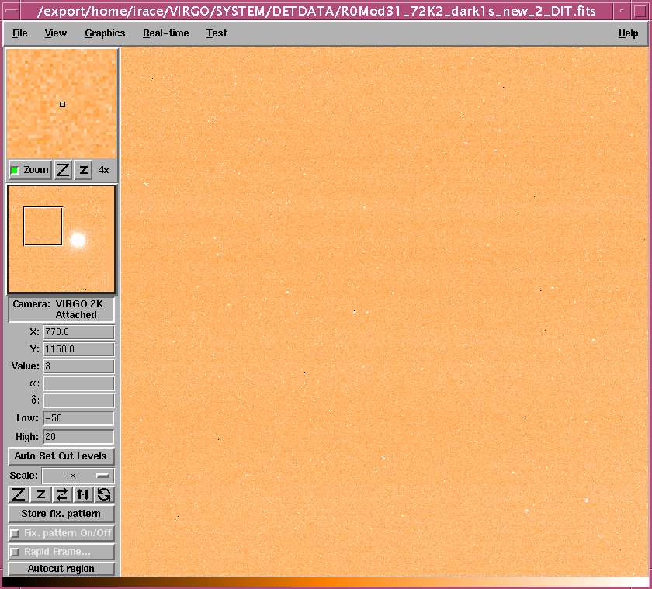
Figure 2: Dark CDS frame obtained with normal CDS sequence

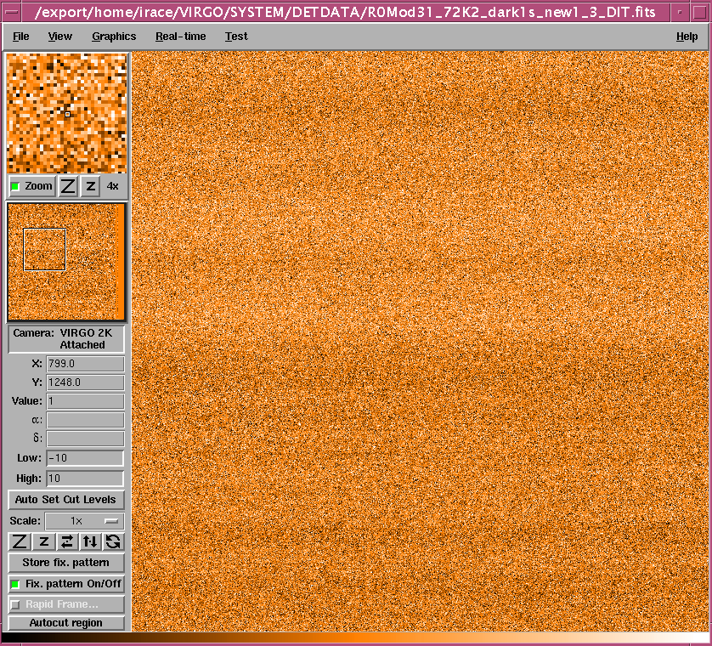
Figure 3: Result of two dark frames (new CDS sequence) subtracted from each other

Light Frames

The fixed pattern is also seen with light input (Figure 4) with new CDS sequence. Subtracting a dark frame from new CDS sequence eliminates the pattern (Figure 5). The sensitivity of the chip has not changed. The counts in similar light frames with normal CDS and with new CDS sequence in a small region away from the defects are same.

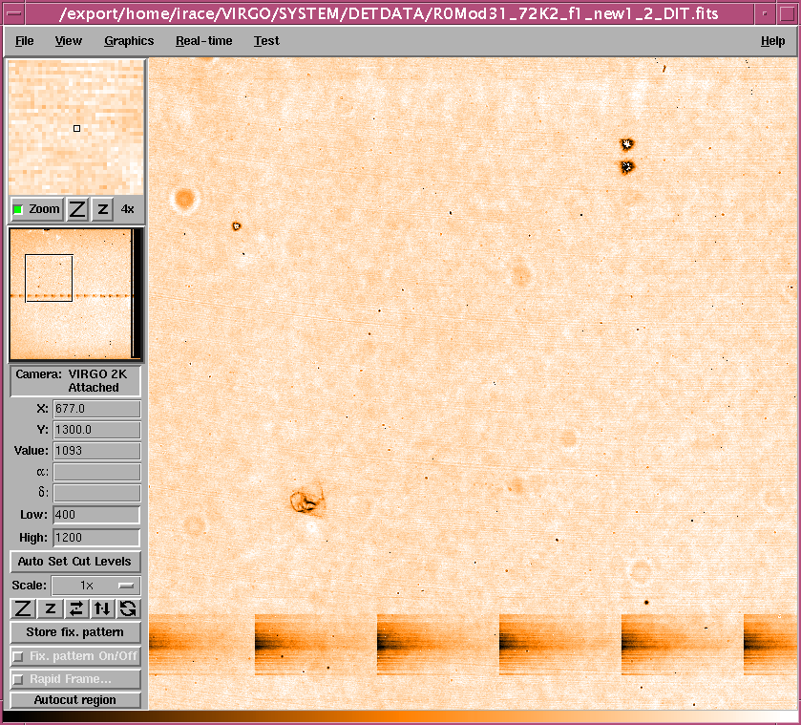
Figure 4: Light frame obtained with new CDS sequence (count level ~1100 ADUs)

It appears that when reading a frame with READRESET, the DC values of the pixels in the rows which have defects in them are slightly lower than with READ alone.
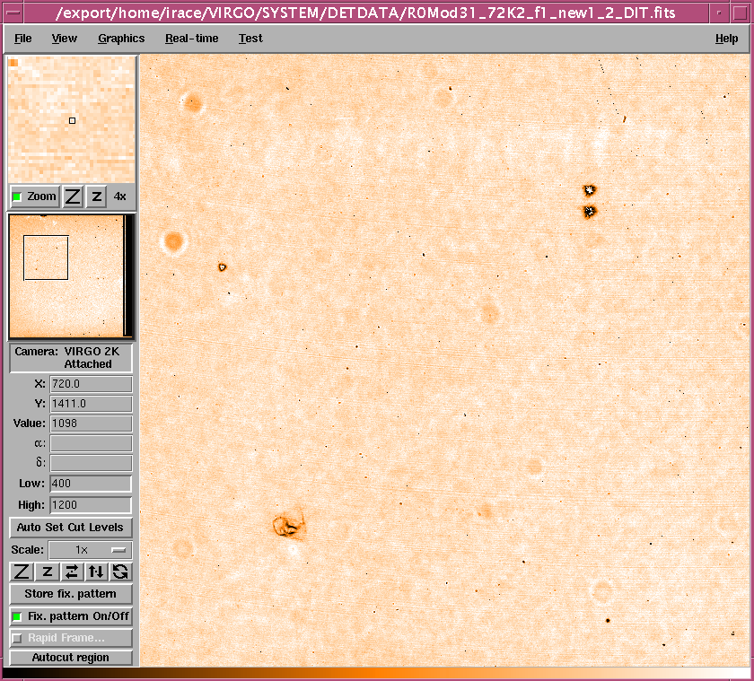
Figure 5: Fixed pattern can be removed by subtracting dark CDS from the light CDS frame (both obtained from new CDS sequence).

Read Noise

The read noise is same in both methods. The read noise in a dark subtracted frame obtained from new CDS sequence is shown in Figure 6. For comparison noise histogram from a normal CDS sequence is shown in Figure 7. This also shows that the fixed pattern noise is subtracted out well.

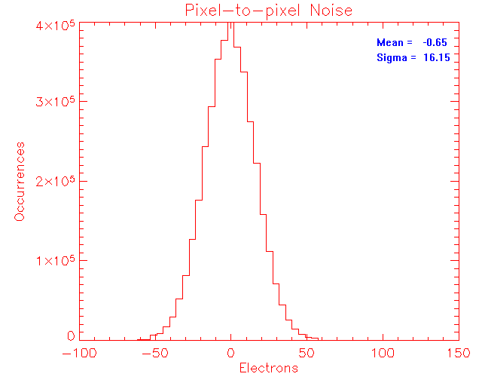
Figure 6: Pixel to pixel noise from new CDS sequence

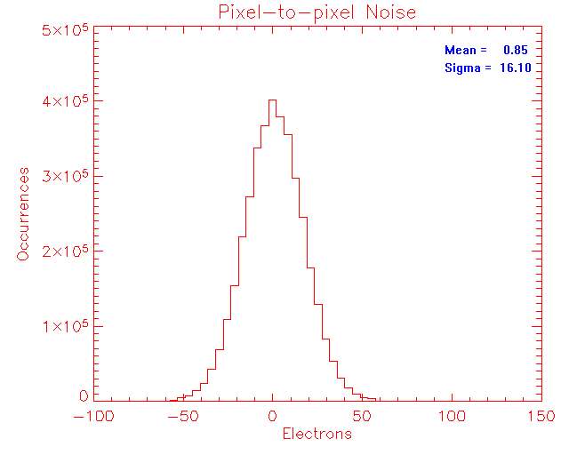
Figure 7: Pixel to pixel noise from a normal CDS sequence

Temporal noise (~15.5e) is also same in both modes.

Conclusions

A new readout mode READRESET has been implemented with the test IRACE at ATC and is tested with the VIRGO detector module#31. The new READRESET mode results some fixed pattern noise in a simple CDS frame. The fixed pattern is along the rows and corresponds to the defects along them. A slight fixed pattern is also seen corresponding to the readout boundaries of the detector. The pattern noise in the frames with READRESET mode subtracts out well. The sensitivity and the noise characteristics of the detector remained unchanged. It is found that the reading a frame with simultaneous resetting results a slightly lower pixel DC values and that is reflected in the CDS frame.

---oOo---

