

IR CAMERA

Document Title: VIRGO Module SCA-38 Test Report

Document Number: VIS-TRE-ATC-06032-1038

Issue: Draft 0.1

Date: 07 January 2005

Document  Prepared By: | Naidu Bezawada  Electronics Engineer | Signature and Date:
Document  Approved By: | Mel Strachan  ATC Project Manager | Signature and Date:
Document Reviewed By: | Gavin Dalton  IR Camera Project Scientist | Signature  And Date:
Document  Reviewed By: | Martin Caldwell  IR Camera Systems Engineer | Signature and Date:
Document  Released By: | Kim Ward  IR Camera Project Manager | Signatures and Date:

The information contained in this document is strictly confidential and is intended for the addressee only. The unauthorised use, disclosure, copying, alteration or distribution of this document is strictly prohibited and may be unlawful.

Change Record

Issue | Date | Section(s) Affected | Description of Change/Change Request Reference/Remarks
Draft 0.1 | 07/01/05 | All | New document

TABLE OF CONTENTS
Change Record 2
1. PERFORMANCE SUMMARY 4
2. DC Uniformity 5
3. System gain and conversion gain 8
4. Read noise 13
5. Dark generation 17
6. Quantum Efficiency 20
7. Persistence 26
8. Open Pixels 29
9. Inoperable Pixels 30
10. Temporal Stability 31
11. Cosmetics 33
12. Read back voltages 34
13. Conclusion 36
Appendix-1 37

PERFORMANCE SUMMARY
Module Number # VM301-38-SCA
Operating temperature 72K
Pixel rate = 294 kHz
Outputs = 16
Frame readout time = 1.001s

Detector bias:
VRstUc = 0.0V
VnUc = 0.5V (0.7V)
VDetCom = 0.5V (0.7V)

Mean DC level = 3.182V @ 0.5V
3.196V @ 0.7V

Detector transimpedance = 2.89µV/e⁻ (20 – 70% of full well)
(0.5V) = 3.17µV/e⁻ (up to ~ 20% of full well)

Dark generation = 1.00e⁻/s/pixel (mean) @0.5V detector bias
Operability = 97.28% (>0, < 8e⁻/s)

Read noise
Temporal = 16.6e⁻ (rms)
Pixel-to-pixel = 17.7e⁻ (rms)

Full well (ke⁻) = 131ke⁻ (@ 0.5V)
174ke⁻ (@ 0.7V)

Non-linearity = 6.3% @0.5V, 5.8% @ 0.7V

QE* | Mean (%) | Sigma | Non-Uniformity  (sigma / mean)
J-Band | 91.4 | 15.0 | 16.4%
H-Band | 103.3 | 6.2 | 6.0%
K-Band | 97.5 | 6.3 | 6.5%
* - Includes only operable pixels

Persistence signal = -3.6e⁻

Total Pixel operability = 97.06%

DC Uniformity
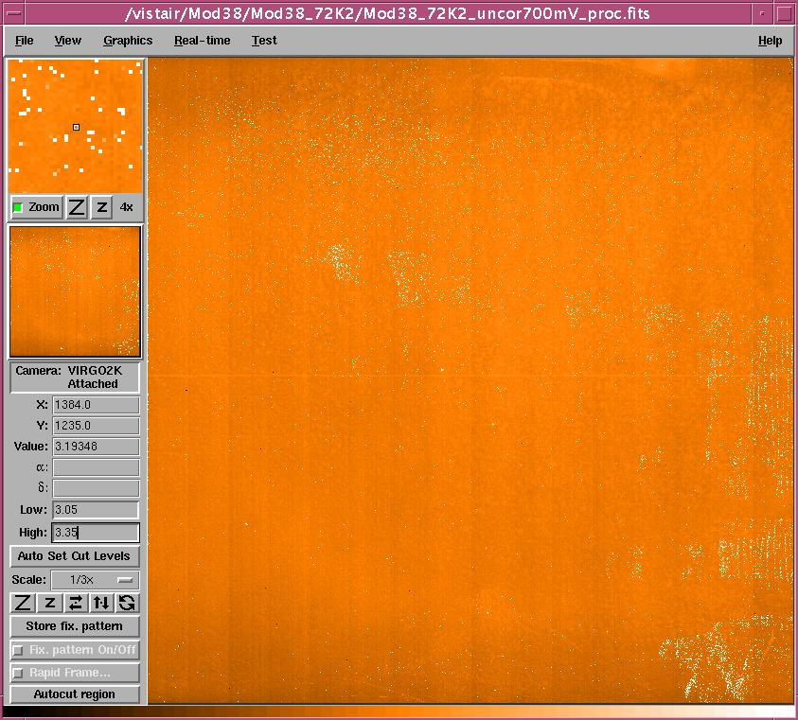

DC Uniformity (0.7V detector bias)

Mean DC @0.5V = 3.182V, Sigma = 0.040V

Mean DC @0.7V = 3.196V, Sigma = 0.060V

High non-uniformity due to high DC pixels (see histograms below)

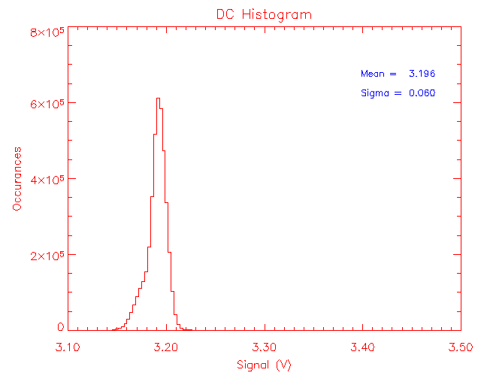
DC Uniformity (Histogram)

Mean DC = 3.196V, Sigma = 0.060V

See histogram below for high DC pixels.

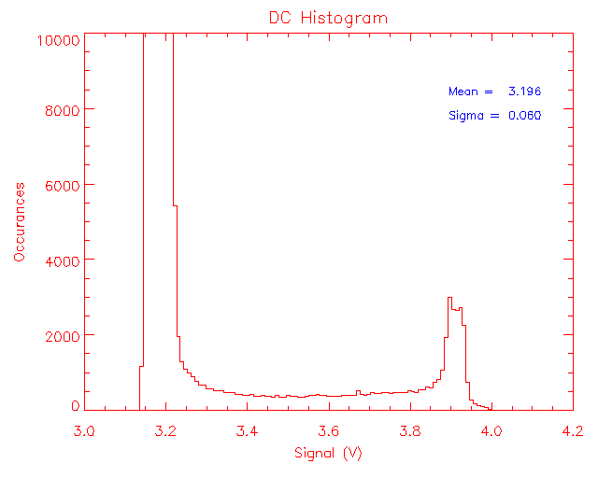

DC histogram – high DC pixels

The DC pixels are seen in the DC uniformity bitmap in the centre and the right side of the array. These are not open pixels but are mostly hot pixels.

System gain and conversion gain

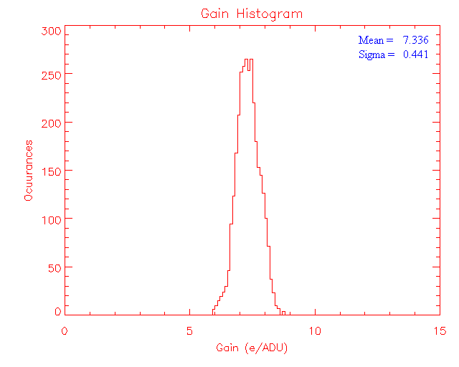

System gain (20 -70% of full well) – 0.7V bias

System gain @ 0.5V bias = 7.891e⁻/ADU
System gain @ 0.7V bias = 7.336e⁻/ADU

The standard deviation is rather high

The array contains lots of hot pixels. The gain is estimated from a region (350:1350, 400:1000) relatively free hot pixels and defects.

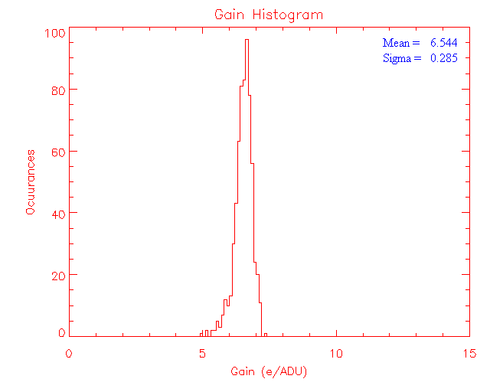
System gain (up to ~20% full well) – 0.7V bias

System gain @ 0.5V bias = 7.199e⁻/ADU
System gain @ 0.7V bias = 6.544e⁻/ADU

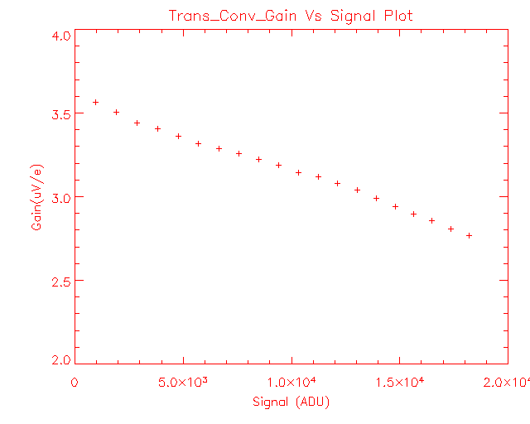
Transimpedance conversion gain vs. signal level (0.7V)

Transimpedance conversion gain @ 0.5V bias = 2.89µV/e⁻ (20 – 70% full well)
= 3.17µV/e⁻ (up to ~20% full well)

Transimpedance conversion gain @ 0.7V bias = 3.12µV/e⁻ (20 – 70% full well)
= 3.48µV/e⁻ (up to ~20% full well)

Conversion gain shows strong dependence on the signal

RVS measured conversion gain is much higher than ATC measurement. RVS measured 3.53µV/e⁻ at 0.5V bias where as ATC value is 2.89µV/e⁻. See the appendix-1 for possible explanation of this discrepancy.

Linearity and full well

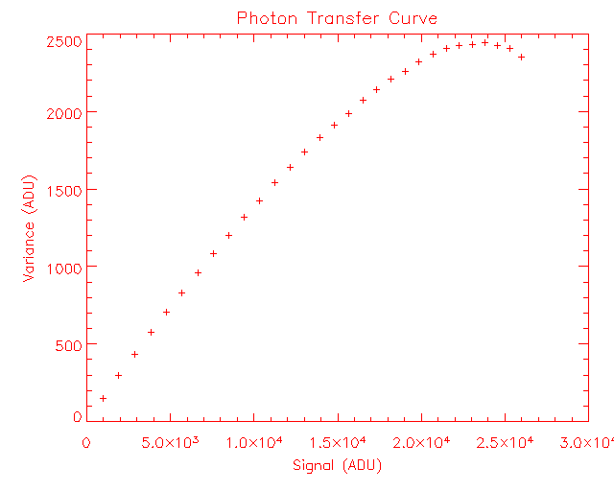
Photon transfer – full well obtained from noise roll-over in the plot (0.7V)

Full well @ 0.5V bias = 131ke⁻

Full well @ 0.7V bias = 174ke⁻

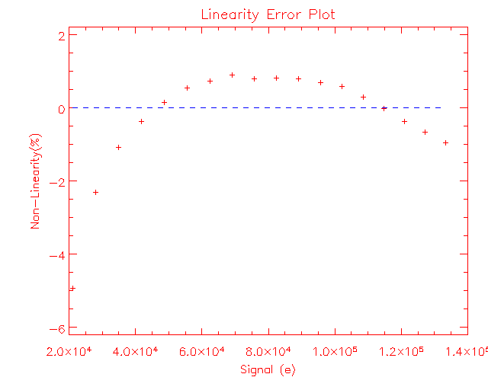

Non-linearity plot (0.7V)

Estimated from 10 – 80% of saturation levels

Non-linearity = ~ 6.3% (0.5V bias)
= ~ 5.8% (0.7V bias)

5% deviation occurs at 101ke⁻ for 0.5V bias
5% deviation occurs at 133ke⁻ for 0.7V bias

Read noise

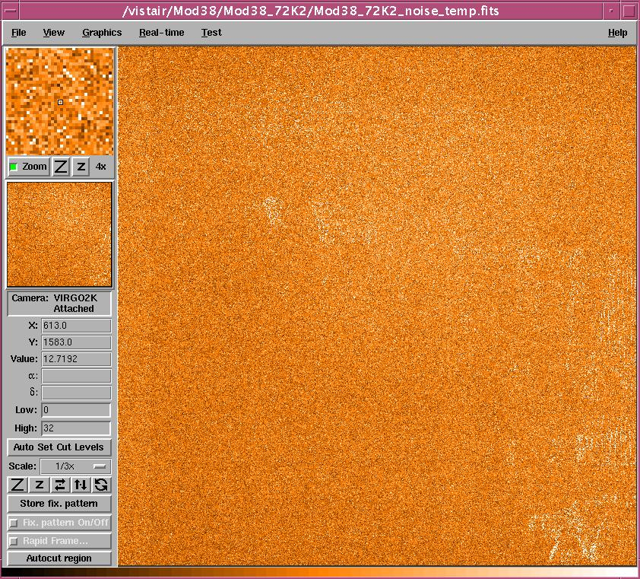

Read noise bitmap (temporal)

Estimated from 10 CDS frames (0.7V)
The array mean read noise (temporal) is 15.7e⁻ (rms).
Number of pixels >32e⁻ noise is 1.8%.

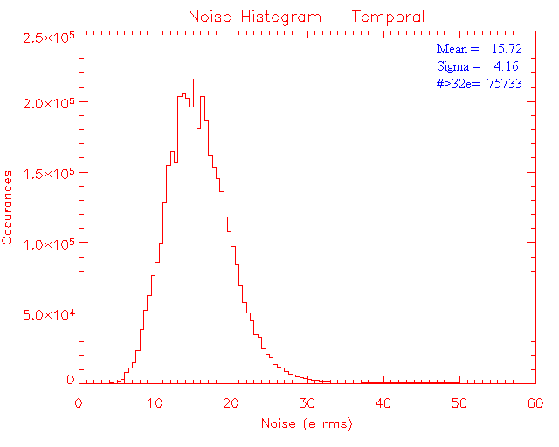
Read noise histogram (temporal)
Obtained from 10 CDS frames with minimum detector integration time

Histogram shows the array mean excluding the pixels >32e⁻
The array mean for all pixels in the frame is 18.1e⁻.

1.8% pixels show read noise >32e.

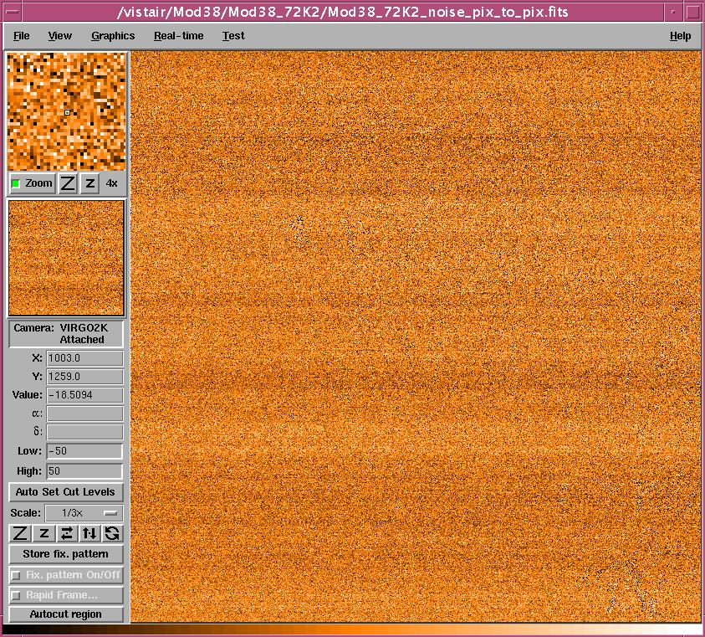

Pixel-to-pixel read noise
Obtained from two 1s dark frames subtracted from each other and divided by root (2)

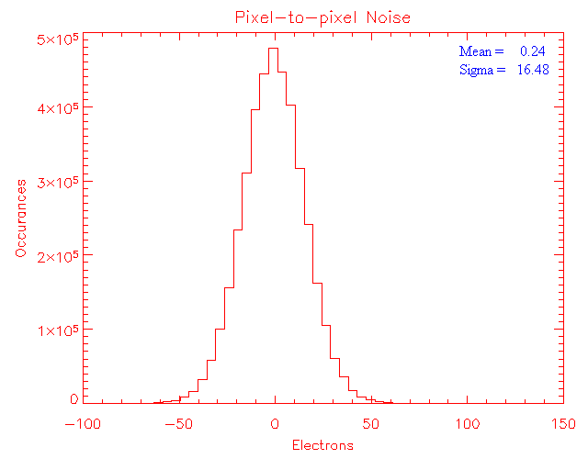
Pixel-to-pixel read noise (excluding pixels with dark > 8e/s)

Obtained from two subsequent dark frames with minimum detector integration time (1s)

The average pixel-to-pixel noise from a sequence of 10 pairs of dark frames is 16.9e⁻(excluding the hot pixels). The sigma of these values is 0.92.
Agrees very close with the temporal noise

Read noise measured the channel-1 = 16.0e⁻.
Read noise from channel-8 = 16.8e⁻.

RVS value for channel-8 is 23.0e⁻.

Dark generation

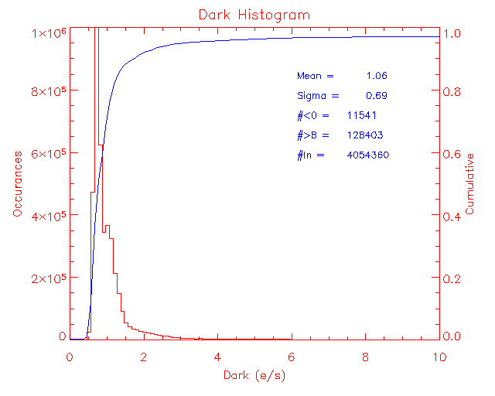
Dark generation (@ 0.7V detector bias)

Measured after a settling time of ~3hrs (i.e. after adjusting any detector bias voltage)
An average of 10 CDS frames (each with 240 sec. integration time) is used to estimate the mean dark generation. Mean dark generation for the full frame excluding pixels with 0 < dark generation > 8e⁻/sec is estimated as 1.06 e⁻/sec/pixel (σ = 0.69). The pixels in limits are ~96.66%.
Mean dark @0.5V bias = 1.00e⁻/s/pix with pixels in limits =97.28 % (with VnUc = 0.7V)
Mean dark @0.7V bias = 1.06e⁻/s/pix with pixels in limits =96.66 % (with VnUc = 0.7V)

96% point in the cumulative histogram = 4.6e⁻/s/pix
97% point = 8.6e⁻/s/pix
98% point = 46.2e⁻/s/pix
99% point = 289.5e⁻/s/pix

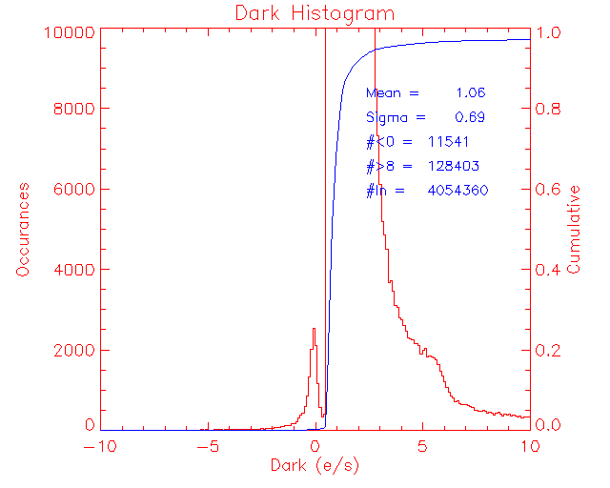

Negative dark pixels ~ 0.28%

Peak close to zero are the high DC pixels in the centre of the detector and right side of the detector (see DC uniformity bit map). There are few (~300) open pixels among these.

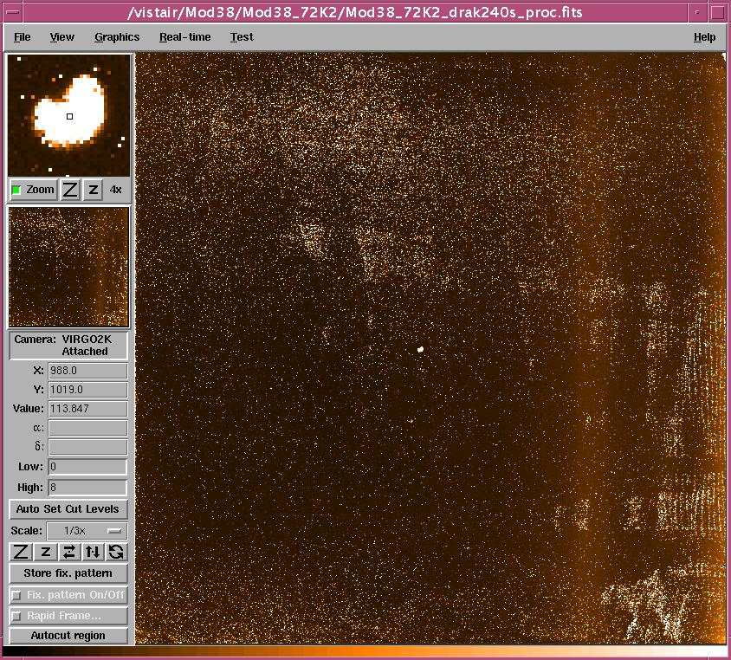

Dark generation bitmap (0.7V detector bias) – mean dark = 1.06e⁻/s/pix. (0 < dark <8)

Dark from a region relatively free from hot pixels (the region used to estimate the system gain and conversion gain) is measured as 0.78e⁻/s/pix.

A hot spot (cluster of hot pixels) in the centre can be more clearly seen in the zoom window. The Zoom window is 36 x 36 pixels.

Quantum Efficiency
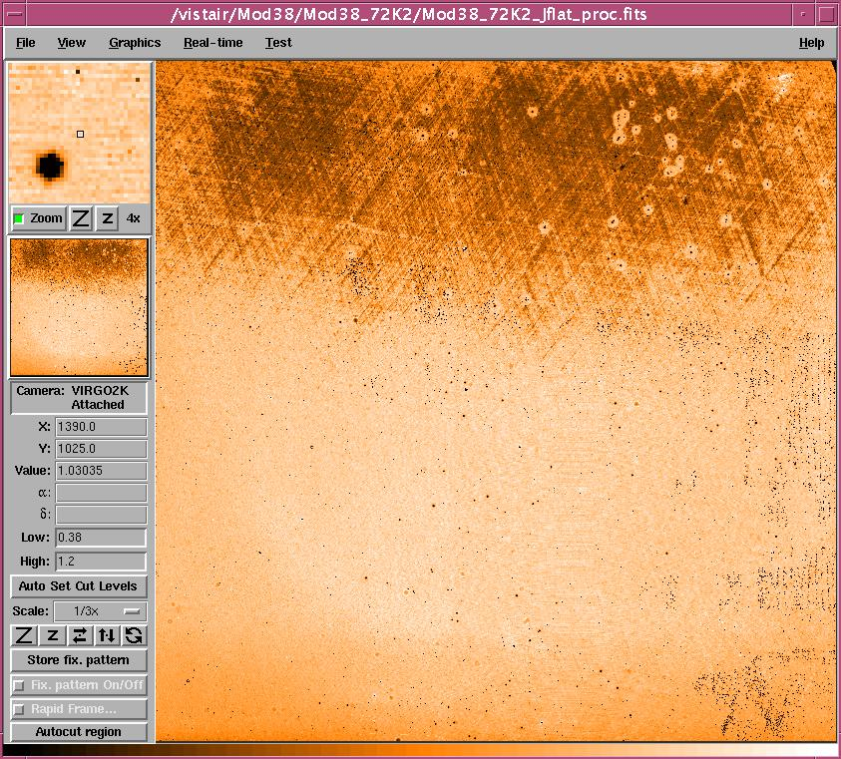

QE bitmap (J-band)
Image stretched between 0.38 and 1.20 limits

Mean = 0.914
Sigma = 0.15

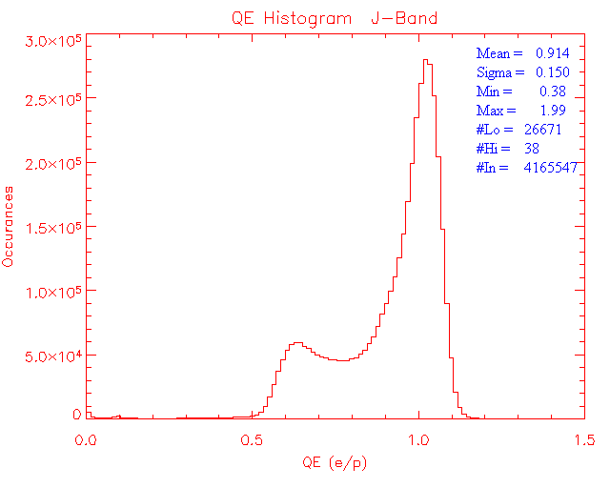
QE histogram (J-band)

Mean and sigma are obtained from operable pixels

Non-uniformity = 16.4% (for pixels in limits)

Operability = 99.36%

Blackbody temperature: low = 350ºC (9.83E8 ph/cm²/s)
High = 380ºC (2.26E9 ph/cm²/s)

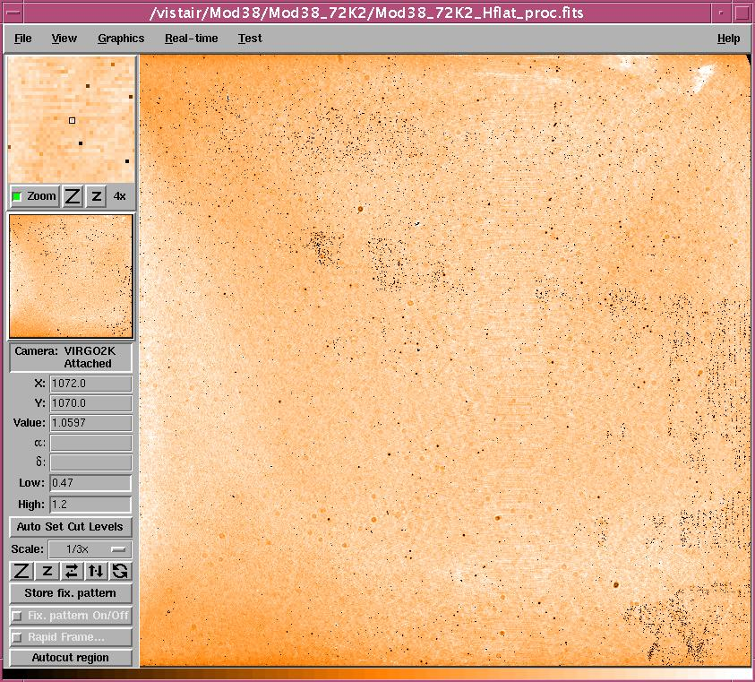

QE bitmap (H-band)

Mean = 1.033
Sigma = 0.062

Image stretched between 0.47 and 1.2 limits

Mean and sigma are obtained from operable pixels

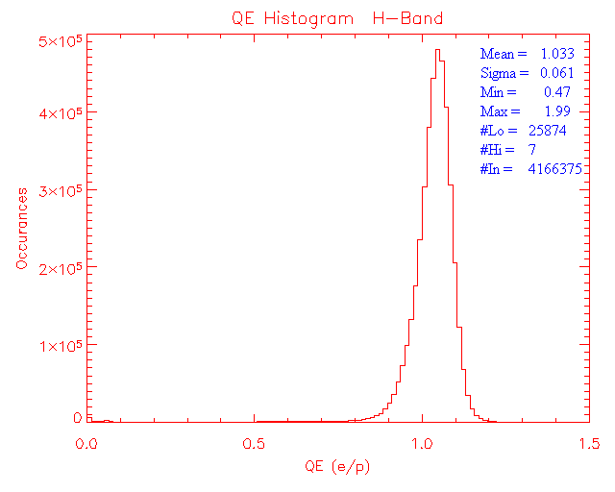
QE histogram (H-band)

Mean and sigma are obtained from operable pixels

Non-uniformity = 6.0% (for pixels in limits)

Operability = 99.38%

Blackbody temperature: low = 220ºC (1.25E9 ph/cm²/s)
High = 250ºC (3.38E9 ph/cm²/s)

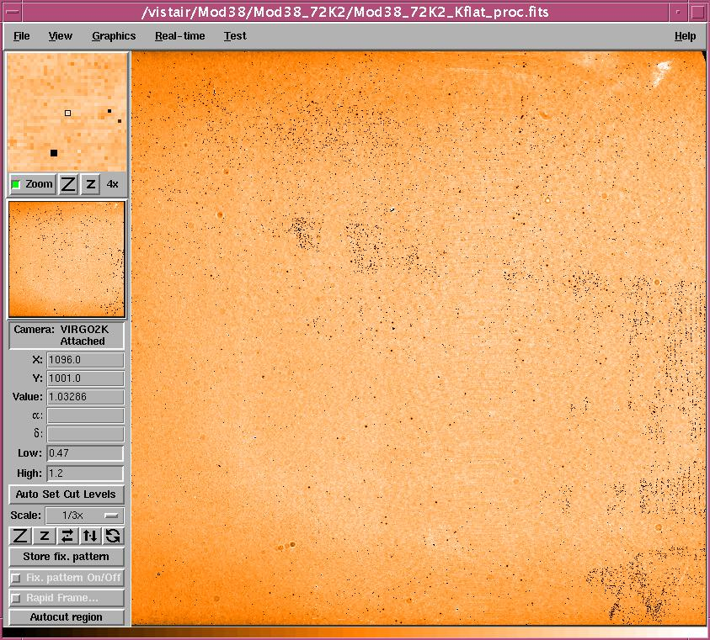

QE bitmap in K-band
Mean = 0.975
Sigma = 0.063

Image stretched between 0.47 and 1.20 limits

Mean and sigma are obtained from operable pixels

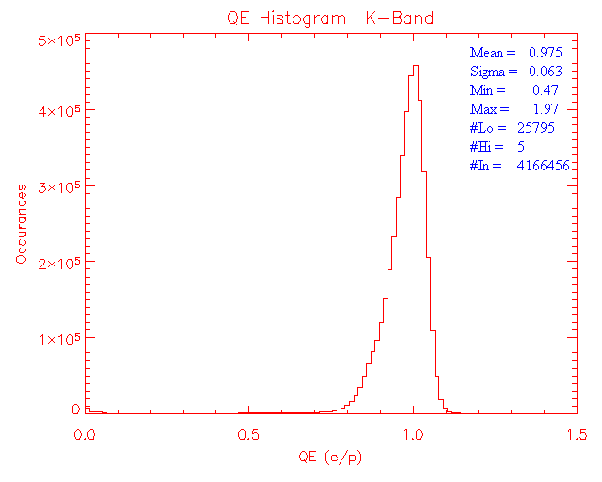
QE histogram (K-band)

Mean and sigma are obtained from operable pixels

Non-uniformity = 6.5% (for pixels in limits)

Operability = 99.38%

Blackbody temperature: low = 120ºC (1.36E9 ph/cm²/s)
High = 150ºC (4.31E9 ph/cm²/s)

Persistence
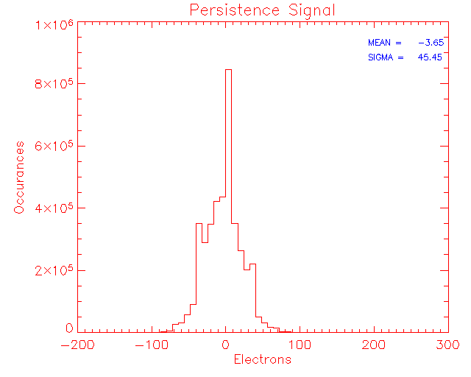
Figure shows the histogram of the persistence signal in a 10s dark after a minute after saturation.

The detector possesses high well capacity (174ke⁻at 0.7V) and so it was not hard saturated with 200ke⁻ fluence and hence negligible persistence after a minute in a 10s dark.

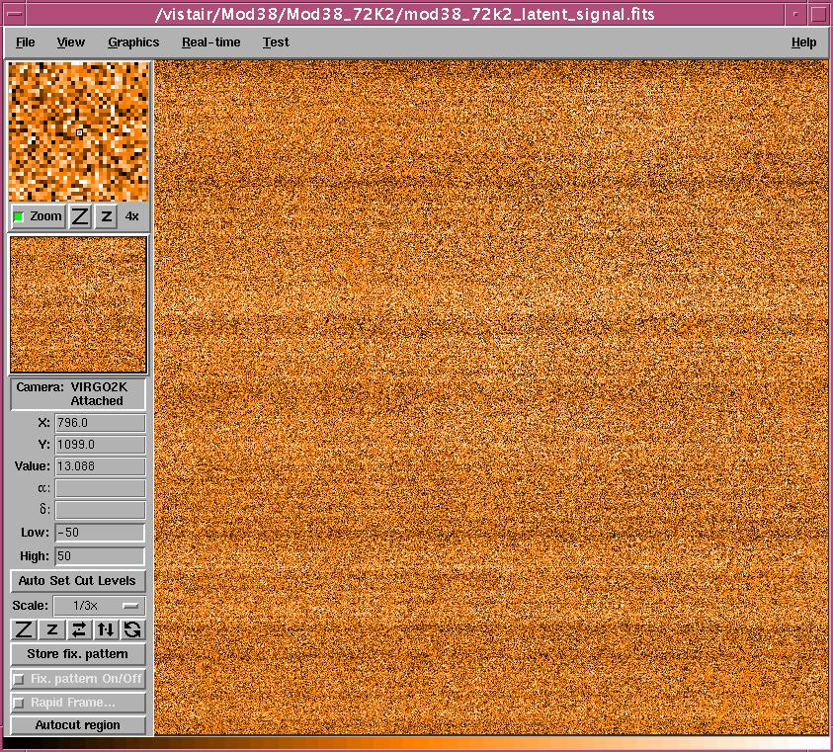

Persistence signal in a 10s dark

Figure shows the persistence signal in a 10s dark after 1 minute after saturation with ~200ke⁻ fluence. The detector is continuously read every 10s after saturation and the persistence decay is obtained.

Persistence signal decay

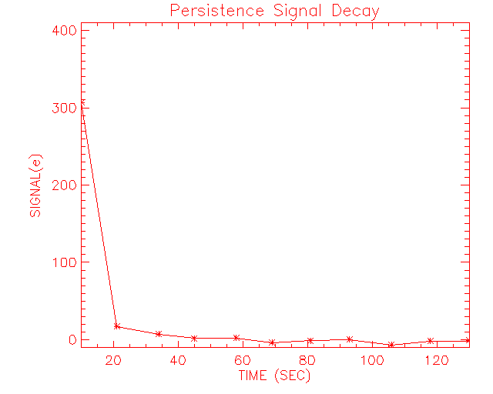
The array mean is -3.6e⁻.

Persistence signal decays below read noise in about ~ 20s.

No persistence after a minute noticed.

Open Pixels

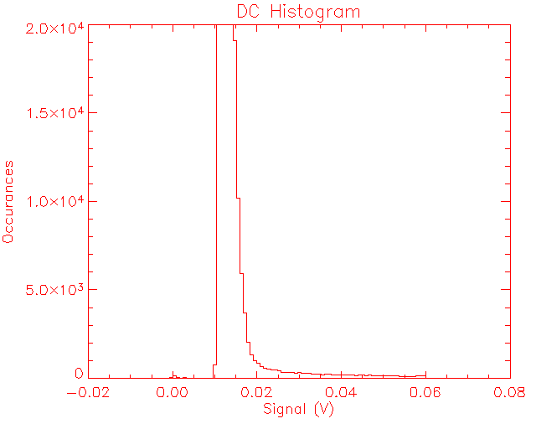
There are 296 open pixels (Pixels without significant DC shift are centred on zero).

Inoperable Pixels
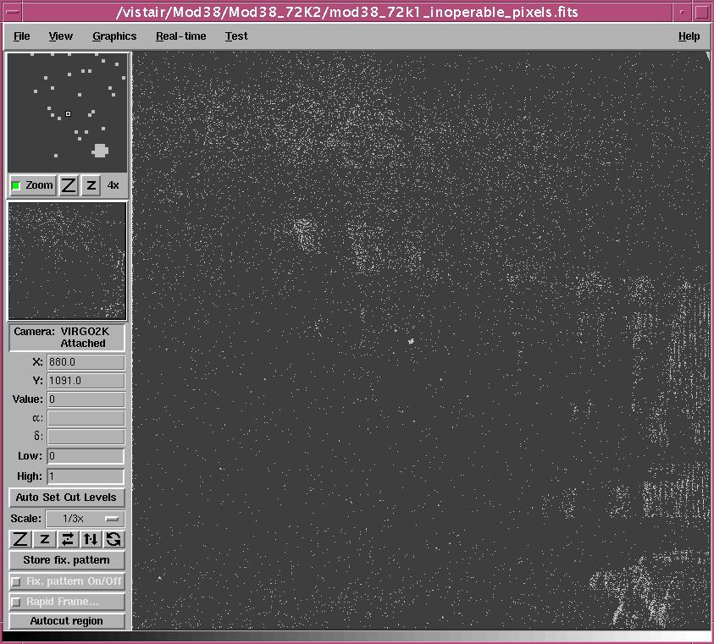

The white spots are the defective pixels. (Obtained from dark operability and QE operability in J, H and K bands)

Total inoperable pixels in the full frame = ~2.94% (0.5V bias)

Temporal Stability
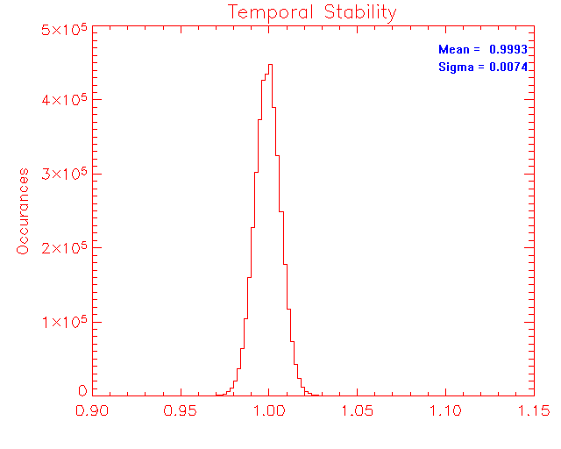
Temporal stability (K-band)

Ratio of two identical flats (50% full well) obtained 4 days apart

Flats are divided by one another and a histogram of the resulted frame is shown above. Inoperable pixels (see bitmap above) have been excluded from the measurement.

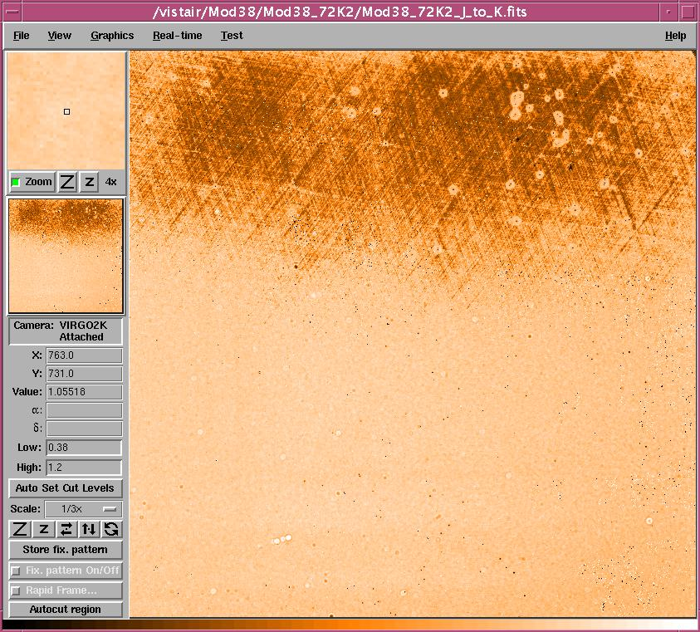

Ratio of J to K flat

Cosmetics
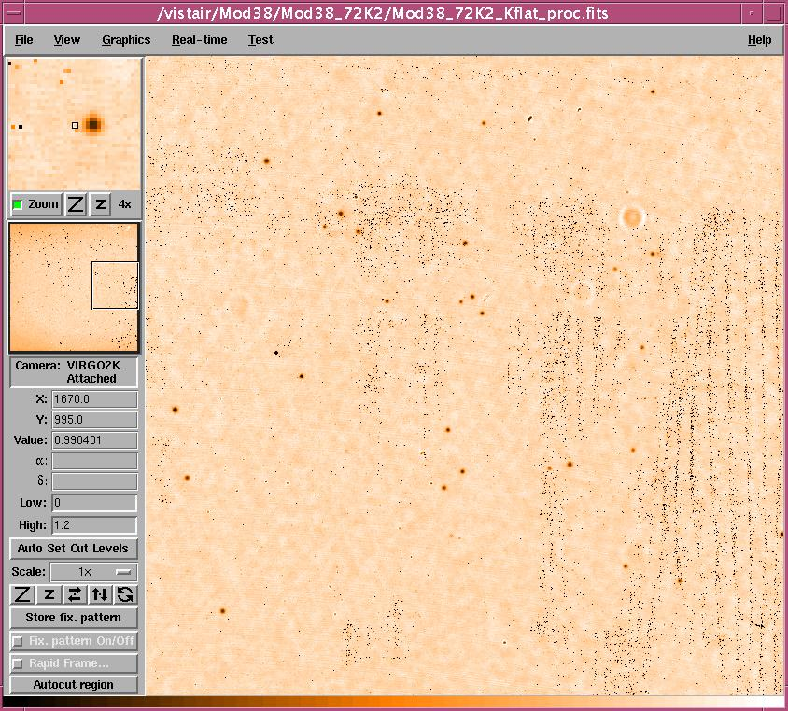
Few defect spots and the stripes of high DC pixels in the selected area.


Top-right corner (shown in a 100 x 100 pixels area)

Read back voltages
Warm (before thermal cycle)
DC | Name | Value1(V) | Value2(V) | Current(mA)
DC1 | vhiReset | 3.999 | 3.979 | 0.20
DC2 | vloReset | 0.005 | 0.005 | -
DC3 | vIdle | -2.363 | -2.344 | 0.19
DC4 | vSlew | -3.999 | -3.970 | 0.29
DC5 | vhiRowEn | 5.000 | 4.971 | 0.29
DC6 | vloRowEn | 0.996 | 1.025 | 0.29
DC7 | vCas | 2.998 | 2.993 | -
DC8 | vpD | 3.999 | 3.970 | 0.29
DC9 | vrstUc | 0.005 | 0.005 | -
DC10 | vpUc | 3.496 | 3.418 | 0.78
DC11 | vnUc | 0.601 | 0.654 | 0.53
DC12 | vnOut | 2.197 | 2.383 | 1.86
DC13 | vdetCom | 0.698 | 0.698 | -
DC14 | vpOut | 9.741 | 9.546 | 1.95
DC15 | vBiasRef | 3.452 | 3.447 | -

Read back voltages – Cold
DC | Name | Value1(V) | Value2(V) | Current(mA)
DC1 | vhiReset | 3.999 | 3.989 | 0.10
DC2 | vloReset | 0.005 | 0.005 | -
DC3 | vIdle | -2.363 | -2.354 | -
DC4 | vSlew | -4.004 | -3.984 | 0.20
DC5 | vhiRowEn | 5.005 | 5.000 | -
DC6 | vloRowEn | 1.001 | 0.996 | -
DC7 | vCas | 2.998 | 2.993 | -
DC8 | vpD | 3.999 | 3.975 | 0.24
DC9 | vrstUc | 0.005 | 0.005 | -
DC10 | vpUc | 3.496 | 3.428 | 0.68
DC11 | vnUc | 0.601 | 0.654 | 0.53
DC12 | vnOut | 2.197 | 2.383 | 1.86
DC13 | vdetCom | 0.698 | 0.698 | -
DC14 | vpOut | 9.746 | 9.556 | 1.90
DC15 | vBiasRef | 3.452 | 3.452 | -

Read back voltages – warm (after thermal cycle)
DC | Name | Value1(V) | Value2(V) | Current(mA)
DC1 | vhiReset | 3.999 | 3.979 | 0.20
DC2 | vloReset | 0.005 | 0.005 | -
DC3 | vIdle | -2.358 | -2.344 | 0.14
DC4 | vSlew | -3.999 | -3.970 | 0.29
DC5 | vhiRowEn | 5.000 | 4.971 | 0.29
DC6 | vloRowEn | 0.996 | 1.025 | 0.29
DC7 | vCas | 2.998 | 2.993 | -
DC8 | vpD | 3.999 | 3.965 | 0.34
DC9 | vrstUc | 0.005 | 0.005 | -
DC10 | vpUc | 3.496 | 3.418 | 0.78
DC11 | vnUc | 0.601 | 0.654 | 0.53
DC12 | vnOut | 2.197 | 2.388 | 1.91
DC13 | vdetCom | 0.698 | 0.698 | -
DC14 | vpOut | 9.741 | 9.541 | 2.00
DC15 | vBiasRef | 3.452 | 3.447 | -

Conclusion
Module#38 shows good performance except for the response in J-band and few high DC and hot pixels. It has very high QE in all bands with good uniformity in H and K. The J-band non-uniformity is high (~16%). The detector has the overall operability ~ 97%.
Transimpedance conversion gain of 2.89µV/e⁻ at 0.5V is measured which is very much different from the RVS value (3.53µV/e⁻). Appendix-1 explains the discrepancy. This detector showed high well capacity. Full well of ~131ke⁻ is obtained with 0.5V (non-linearity ~6.3%) while full well of ~174ke⁻ is achieved at 0.7V bias (non-linearity ~ 5.8%). The 5% deviation occurs around 100ke⁻ at 0.5V and ~133ke⁻ at 0.7V bias respectively.
The detector shows ~3% hot pixels including the high DC pixels which are about 1%. These pixels are also seen in the RVS data. A mean dark generation of 1.06e⁻/s/pix is measured at 0.7V (1.00e⁻/s/pix @ 0.5V) with dark pixel operability ~97% (0 < dark < 8e⁻/s/pix). Mean dark measured from a region relatively free from high DC and hot pixels is ~0.78e⁻/s/pix.
High QE over 90% have been measured in all bands. RVS reported QEs in J (57%), H (74%) and K (74%) differ from ATC measurements in all bands. The possible explanation lies in the RVS conversion gain measurement as explained in appendix-1.
The array shows low read noise both temporal noise (16.6e⁻) and pixel-to-pixel noise (17.6e⁻) and are below RVS value from Channel-8 (23e⁻).
This detector showed negligible persistence. This is because as the detector has high well capacity (174ke⁻), at 200ke⁻ fluence it is not hard saturated and hence no persistence observed after a minute. Persistence signal decays below 32e⁻ in about 20s.
This detector shows sparsely located defect spots across the array. No cosmic events have been noticed during the tests of this detector.
Overall, this detector meets the pixel operability and meets QE, dark, read noise and persistence specifications. Although some portion of the array shows poor response in J-band (the response looks strange with criss-cross patterns), it still meets the operability in J-band and hence should be considered as Science Grade detector.

---oOo---

Appendix-1
The plot below shows the RVS values for signal and variance measurements (taken from the data pack).

RVS have used three data points (3rd, 4th and 8th) out of 8 data points for the photon transfer which gives the transimpedance conversion gain as 3.532µV/e⁻ (the slope of the green line – linear fit). The blue line is a linear fit for all data points which gives the conversion gain as 2.619µV/e⁻ which is less by ~ 26%. The later value is more close to the ATC measurement of 2.89µV/e⁻ which is less by ~18%. The effect of this difference is that the RVS QE values would go up by 18 – 26% than reported if correct conversion gain value is used.

