

IR CAMERA

Document Title: Report on EMC tests with Science Detectors

Document Number: VIS-TRE-Number to be given

Issue: Draft 0.1

Date: 19 November 2007

Document  Prepared By: | Naidu Bezawada  Guy Woodhouse  Malcolm Stewart | Signature and Date:
Document  Reviewed By: | Martin Caldwell  IR Camera Systems Engineer | Signature and Date:
Document  Released By: | Kim Ward  IR Camera Project Manager | Signatures and Date:

The information contained in this document is strictly confidential and is intended for the addressee only. The unauthorised use, disclosure, copying, alteration or distribution of this document is strictly prohibited and may be unlawful.

Change Record

Issue | Date | Section(s) Affected | Description of Change/Change Request Reference/Remarks
Draft 0.1 | 19/11/07 | All | New document

TABLE OF CONTENTS
Change Record 2
1. Introduction 4
2. All CCDs on Condition 4
3. EMC Tests with J filter 9
4. All Other Conditions 11
5. Dark Generation 11
6. Conclusions 12

Introduction
This document presents the results of the EMC tests with the science detectors in the IR Camera cool down during 16-Oct to 06-Nov 07. In order to check the EMC effects due to the operation of the technical CCDs on the science detectors in the IR camera, several dark frames (with min detector integration time) were obtained and analysed visually and statistically. The read noise in the dark frames is obtained by subtracting two identical dark frames and by dividing the resultant frame by square root of 2. The ADUs have been converted into electrons by using the system gain for each detector that was established during the earlier AIT tests. Dark frames were obtained with all the CCD systems in shutdown mode and in following other configurations: only AG1 is on, only AG2 on, only WFS1 on, only WFS2 on and all on. The ‘all-ccds-off’ and ‘all-ccds-on’ conditions were analysed in all readout channels for all sixteen detectors.

All CCDs on Condition
The Figures 1, 2 shows the read noise measured for readout channels 1 and 2 for all 16 detectors with the ‘all-ccds-off’ and ‘all-ccds-on’ conditions. As can be seen, there is a very little increase in the readout noise when all ccd systems were running. There is almost no change in some of the detectors. Some of the channels of the detector 8 and detector 13 show high read noise (high-lighted cells) in both cases. All the defects and the hot pixels are masked in the noise analysis. Table1 (1a to 1d) presents the measured read noise levels in all channels for all the sixteen detectors.

Figure 1: Readout noise in Channnel#1
Figure 2: Readout noise in channel#2

Detector  # | Ch-1 |  | Ch-2 |  | Ch-3 |  | Ch-4
Detector  # | ccds_off | ccds_on | ccds_off | ccds_on | ccds_off | ccds_on | ccds_off | ccds_on
1 | 20.5 | 21.2 | 21.8 | 21.6 | 20.8 | 21.3 | 21.3 | 21.3
2 | 19.1 | 20.1 | 18.9 | 19.9 | 18.9 | 19.9 | 19.1 | 20.3
3 | 18.1 | 18.6 | 18.9 | 19.6 | 19.8 | 20.3 | 21.9 | 22.4
4 | 19.6 | 20.6 | 19.5 | 20.2 | 19.6 | 20.3 | 21.3 | 22.0
5 | 22.1 | 22.5 | 22.6 | 22.9 | 22.2 | 22.6 | 22.4 | 22.7
6 | 20.4 | 20.4 | 18.7 | 19.1 | 19.4 | 19.8 | 20.3 | 20.7
7 | 23.0 | 23.3 | 22.1 | 22.4 | 22.2 | 22.4 | 22.3 | 22.6
8 | 18.9 | 22.6 | 19.1 | 19.7 | 19.1 | 19.6 | 19.8 | 20.3
9 | 17.7 | 17.6 | 17.2 | 17.9 | 17.4 | 17.5 | 17.0 | 17.0
10 | 22.8 | 22.8 | 21.9 | 21.8 | 22.3 | 22.2 | 22.5 | 22.5
11 | 22.3 | 22.2 | 21.8 | 21.6 | 22.1 | 22.0 | 22.7 | 23.0
12 | 22.0 | 21.9 | 22.1 | 22.1 | 22.6 | 22.6 | 23.2 | 23.0
13 | 20.1 | 20.3 | 20.6 | 20.2 | 19.9 | 21.6 | 21.8 | 20.5
14 | 14.9 | 15.2 | 14.7 | 14.9 | 15.1 | 15.1 | 18.6 | 33.6
15 | 17.2 | 17.3 | 17.1 | 17.4 | 17.1 | 17.3 | 17.4 | 17.6
16 | 15.8 | 15.9 | 15.5 | 15.7 | 16.1 | 16.3 | 16.1 | 16.2
Table 1a: Read noise of Ch 1 - 4

Detector  # | Ch-5 |  | Ch-6 |  | Ch-7 |  | Ch-8
Detector  # | ccds_off | ccds_on | ccds_off | ccds_on | ccds_off | ccds_on | ccds_off | ccds_on
1 | 20.9 | 21.8 | 20.9 | 21.3 | 21.3 | 21.7 | 21.1 | 21.4
2 | 19.5 | 20.5 | 19.5 | 20.2 | 29.8 | 20.5 | 19.1 | 20.1
3 | 21.1 | 21.5 | 20.9 | 21.4 | 20.7 | 21.3 | 20.2 | 20.9
4 | 22.2 | 22.9 | 22.9 | 23.5 | 25.0 | 25.5 | 25.6 | 26.1
5 | 22.6 | 22.9 | 22.6 | 22.9 | 22.7 | 23.1 | 22.8 | 23.0
6 | 20.8 | 21.2 | 20.7 | 21.1 | 21.0 | 21.5 | 21.9 | 21.5
7 | 22.7 | 22.9 | 22.4 | 22.8 | 22.8 | 23.1 | 22.6 | 22.9
8 | 34.5 | 22.4 | 25.6 | 25.6 | 30.6 | 31.0 | 35.2 | 35.0
9 | 17.3 | 17.3 | 18.3 | 17.1 | 17.4 | 17.5 | 17.1 | 17.0
10 | 22.7 | 22.6 | 23.0 | 23.0 | 23.2 | 23.1 | 23.3 | 23.4
11 | 23.4 | 23.2 | 23.6 | 23.6 | 24.5 | 24.3 | 25.1 | 25.0
12 | 23.7 | 23.8 | 24.8 | 24.5 | 28.2 | 28.1 | 27.8 | 27.6
13 | 41.5 | 43.7 | 36.5 | 29.0 | 28.9 | 29.3 | 27.3 | 36.1
14 | 17.8 | 18.3 | 17.3 | 17.8 | 16.1 | 17.4 | 15.1 | 15.4
15 | 17.4 | 17.6 | 17.3 | 17.4 | 17.2 | 17.3 | 17.1 | 17.1
16 | 16.5 | 16.6 | 17.4 | 17.5 | 18.9 | 19.0 | 17.6 | 17.7
Table 1b: Read noise of Ch 5 - 8

Detector  # | Ch-9 |  | Ch-10 |  | Ch-11 |  | Ch-12
Detector  # | ccds_off | ccds_on | ccds_off | ccds_on | ccds_off | ccds_on | ccds_off | ccds_on
1 | 21.5 | 22.3 | 22.4 | 22.2 | 24.4 | 24.9 | 22.0 | 22.4
2 | 19.3 | 19.9 | 19.1 | 19.8 | 19.3 | 19.9 | 19.1 | 20.0
3 | 18.7 | 19.4 | 18.0 | 18.6 | 18.2 | 18.5 | 18.0 | 18.8
4 | 24.0 | 24.7 | 23.0 | 23.5 | 21.6 | 22.2 | 21.4 | 21.9
5 | 22.9 | 23.2 | 22.7 | 23.1 | 22.8 | 23.1 | 22.7 | 23.0
6 | 21.5 | 22.0 | 20.6 | 21.1 | 20.0 | 20.3 | 18.8 | 19.3
7 | 22.6 | 22.7 | 22.5 | 22.8 | 22.3 | 22.6 | 22.1 | 22.2
8 | 40.0 | 39.9 | 40.8 | 41.4 | 39.2 | 39.9 | 35.9 | 36.6
9 | 17.3 | 17.2 | 16.8 | 17.0 | 16.9 | 16.8 | 17.6 | 16.7
10 | 23.6 | 23.6 | 23.5 | 23.4 | 23.6 | 23.5 | 23.5 | 23.4
11 | 25.9 | 26.0 | 25.5 | 25.4 | 25.6 | 25.4 | 25.1 | 24.9
12 | 27.6 | 27.5 | 26.7 | 27.0 | 25.8 | 25.9 | 25.0 | 24.9
13 | 32.1 | 30.1 | 35.3 | 32.0 | 37.3 | 37.0 | 85.5 | 56.0
14 | 15.5 | 15.9 | 15.3 | 15.3 | 15.9 | 16.0 | 18.2 | 18.6
15 | 17.7 | 17.6 | 26.7 | 23.1 | 17.3 | 17.3 | 18.2 | 18.3
16 | 18.1 | 18.3 | 18.6 | 18.8 | 19.7 | 19.9 | 18.7 | 20.3
Table 1c: Read noise of Ch 9 - 12

Detector  # | Ch-13 |  | Ch-14 |  | Ch-15 |  | Ch-16
Detector  # | ccds_off | ccds_on | ccds_off | ccds_on | ccds_off | ccds_on | ccds_off | ccds_on
1 | 21.0 | 22.2 | 21.1 | 21.2 | 21.3 | 22.3 | 25.7 | 23.8
2 | 19.0 | 20.0 | 19.7 | 20.4 | 19.2 | 20.0 | 19.3 | 20.0
3 | 17.6 | 18.2 | 17.5 | 18.1 | 17.5 | 18.2 | 18.2 | 18.8
4 | 20.4 | 21.1 | 23.9 | 24.4 | 21.6 | 22.0 | 22.4 | 23.6
5 | 25.5 | 23.1 | 22.8 | 23.1 | 22.6 | 23.0 | 22.8 | 23.2
6 | 18.0 | 18.5 | 17.5 | 17.8 | 17.1 | 17.5 | 16.8 | 17.2
7 | 22.0 | 22.3 | 22.2 | 22.6 | 22.1 | 22.5 | 22.4 | 22.6
8 | 31.3 | 31.7 | 28.4 | 28.6 | 24.8 | 25.3 | 23.3 | 23.8
9 | 16.8 | 16.8 | 16.9 | 16.7 | 16.4 | 16.4 | 17.4 | 17.4
10 | 23.2 | 23.2 | 23.2 | 23.2 | 23.4 | 23.4 | 23.9 | 23.8
11 | 24.8 | 24.8 | 24.9 | 24.8 | 24.0 | 23.7 | 24.0 | 23.8
12 | 23.7 | 23.6 | 24.0 | 23.9 | 23.2 | 23.1 | 23.6 | 24.0
13 | 38.0 | 36.6 | 50.8 | 36.5 | 45.5 | 33.9 | 26.1 | 36.4
14 | 16.1 | 16.0 | 15.9 | 16.0 | 15.3 | 15.2 | 16.3 | 16.6
15 | 17.6 | 17.4 | 17.6 | 17.6 | 17.7 | 17.9 | 20.5 | 21.7
16 | 18.4 | 18.6 | 19.8 | 24.0 | 18.7 | 18.8 | 20.5 | 20.7
Table 1d: Read noise of Ch 13 - 16

In order to check the difference between the ‘all-ccds-off’ and ‘all-ccds-on’ conditions, the difference dark frames for few detectors were stretched and analysed visually for any patterns due to EMC. The Figures 3 and 4 show the difference dark frames in both conditions for detector #6. As can be seen, the horizontal banding is slightly more prominent with the ‘all-ccds-on’ conditions. This is true for all the other detectors also.

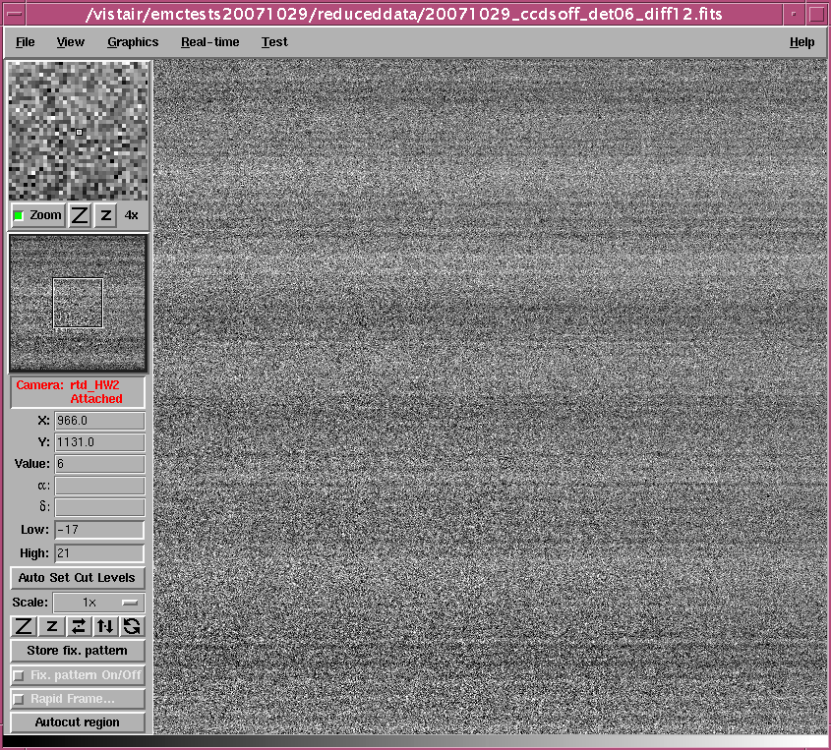
Figure 3: Difference frame (detector#6) in ‘all-ccds-off’ condition

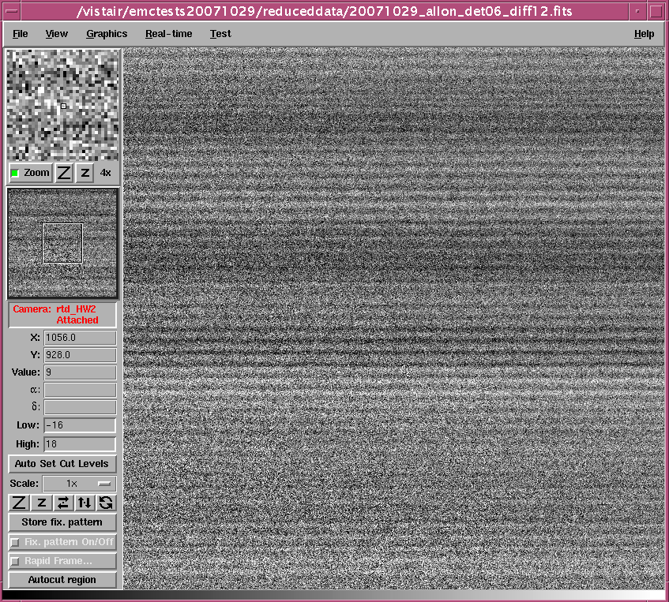
Figure 4: Difference frame (detector#6) in ‘all-ccds-on’ condition

EMC Tests with J filter
Few frames were obtained with J filter positioned in front of the detectors. Due to a problem in positioning the filter wheel, the filter did not position correctly after moving from sunblind to J filter. Some detectors were under the filter whilst some others still remained under the sunblind filter as seen in Figure 5. The detectors that were fully under sunblind and the detectors that were under partial sunblind were analysed to see if the glass above the detectors show an increase in the EMC coupling. The detectors 1, 5, 9 and 13 are under the sunblind whilst the detectors 2, 6 and 10 are partially under the sunblind. The data of these detectors were analysed in the same way as before and the results are shown in the table below. The data from detector 13 is not used as it showed high read noise. The data from the readout channels far end of the glass is used in the noise analysis.
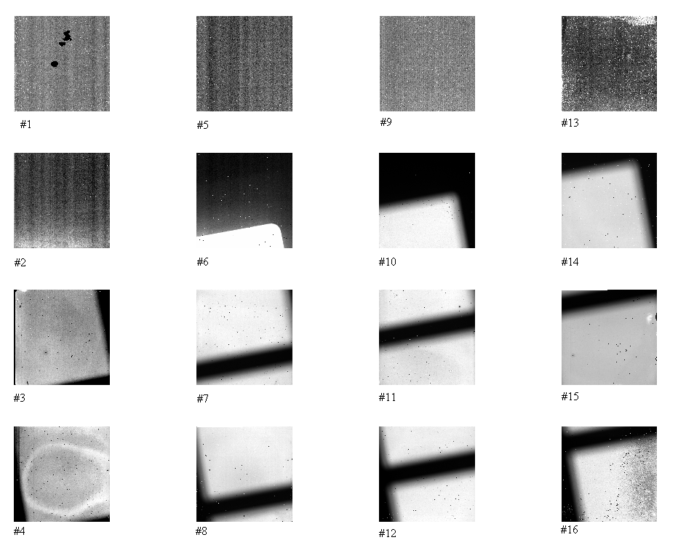
Figure 5: Images with J filter misaligned with the detectors. Detectors 1, 5, 9 and 13 are still under sunblind whilst detectors 2, 6 and 10 are under partial sunblind

Detector  # | Ch-1 |  | Ch-2
Detector  # | Under sunblind | Still under sunblind (with J filter) | Under sunblind | Still under sunblind (with J filter)
1 | 22.2 | 21.5 | 21.2 | 22.3
2 | 20.0 | 20.6 | 20.4 | 20.6
5 | 23.1 | 21.9 | 23.1 | 22.9
6 | 18.5 | 21.4 | 17.8 | 19.9
9 | 16.8 | 18.7 | 16.7 | 18.2
10 | 23.2 | 25.2 | 23.2 | 24.5
Table 2: Read noise measured from detectors still under sunblind and under partial sunblind

As can be seen from the above table, there is almost no change with the detectors 1, 5 and 9 which were fully under sunblind whilst a slight increasing trend can be seen with the detector 2, 6 and 10 which were under partial sunblind. In order to establish this clearly, more number of readout channels of the detector 6 (11 channels spanning from far end to the edge of the filter) were analysed and compared with the read noise obtained with ‘all_ccds_on’ condition. The following Table presents the details.

Detector #6  Channel | Read noise  All_ccds_on  Under sunblind  (e⁻ rms) | Total noise  J-Filter  Partial sunblind  (e⁻ rms) | Average Signal (e⁻)  (due to scattered light) | Expected noise (e⁻ rms)  (read noise + shot noise in quadrature)
1 | 20.4 | 21.4 | 38 | 21.3
2 | 19.1 | 19.9 | 42 | 20.2
3 | 19.8 | 20.6 | 49 | 21.0
4 | 20.7 | 22.0 | 64 | 22.2
5 | 21.2 | 23.1 | 85 | 23.1
6 | 21.1 | 23.4 | 108 | 23.5
7 | 21.5 | 24.1 | 127 | 24.3
8 | 21.5 | 24.5 | 147 | 24.7
9 | 22.0 | 25.4 | 178 | 25.7
10 | 21.1 | 26.1 | 221 | 25.8
11 | 20.3 | 26.5 | 278 | 26.3
Table 3: Detector 6 readout noise data under complete sunblind and under partial sunblind

Table shows that the total noise measured under the partial sunblind is the readout noise added in quadrature with the shot noise due to the scattered light. As the measured noise is close to the expected total noise, there seems to be no additional EMC coupling in the data.

All Other Conditions
Data from the other conditions such as AG1 only on, AG2 only on, WFS1 only on and WFS2 only on were also analysed and the noise measured is more or less same as with the ‘all_ccds_on’ condition. It’s hard to distinguish any clear differences.

Dark Generation
In order to investigate why detector 13 showed high read noise, dark generation of the detectors were checked. The dark generation is estimated from co-adds of 20 dark CDS frames each with 60s integration period (‘all_ccds_off’ condition). The following table shows the mean dark generations.

Detector  # | Mean dark (e/pixel/sec) | % Pixels < 0 e/pixel/sec | % Pixels > 8  e/pixel/sec
1 | 1.83 | 1.5 | 2.5
2 | 2.46 | 0.0 | 2.9
3 | 5.45 | 0.2 | 11.8
4 | 2.15 | 0.0 | 3.2
5 | 0.69 | 0.0 | 0.7
6 | 0.73 | 0.0 | 1.1
7 | 0.96 | 0.0 | 1.4
8 | 0.94 | 0.2 | 2.8
9 | 0.94 | 0.0 | 2.0
10 | 0.48 | 0.0 | 0.1
11 | 0.87 | 0.1 | 2.2
12 | 0.76 | 0.1 | 1.5
13 | 22.0 | 0.2 | 98.5
14 | 3.79 | 0.1 | 55.0
15 | 0.46 | 1.3 | 1.1
16 | 1.14 | 0.3 | 5.6
Table 4: Dark estimated from co-adds of 20 CDS dark frames each with 60s integration

The detectors 3, 13 and 14 show high dark generations as well as large percentage of pixels above 8e/s/pix spec. The test reports show that these two detectors showed similar mean dark generations, but only a few percent of pixels were above 8e/s/pix. For example, the detector 13 (SCA#30) showed a mean dark of 3.85e/s/pix and only ~6.5% pixels above 8e/s/pix. The detector 14 (SCA#43) showed a mean dark of 1.2e/s/pix and only ~6% pixels above 8e/s/pix. There is something unusual with these detectors. As the read noise estimated in Table 1 used pixels only within limits (0<dark<8), the estimates for detector 13 is not reliable as only ~1% pixels were used.

Conclusions
There is a slight increase in the readout noise with the IR detectors when all the CCD systems are running (reading + transferring). The increase in the noise is very little compared to the normal readout noise. The partial sunblind images showed no further increase in the EMC coupling compared to the total sunblind frames. The increase in the measured noise is entirely due to the shot noise associated with the scattering of light. Detectors 13 and 14 showed unusual dark characteristics and needs further tests to understand their behaviour.

---oOo---

