Data Flow System

Document Title: VISTA Infra Red Camera DFS User
Requirements

Document Number: VIS-SPE-IOA-20000-0001

Issue: 0.5

Date: 2004-04-08

Document  Prepared by: | Peter Bunclark  (CASU) | Signature  And date:
Document  Approved by: | Mike Irwin  (CASU Manager) | Signature  And date:
Document  Released by: | Jim Emerson  (VDFS Project leader) | Signature  And date:
Document  Reviewed by: | William Sutherland  (VISTA Project Scientist) | Signature  And date:

Change Record

Issue | Date | Sections Affected | Description of Change/Change Request Reference/Remarks
0.5 | 2004-04-08 | All | New document

Notification List
The following people should be notified by email that a new version of this document has been issued:

IoA |  | W Sutherland
Oxford |  | G Dalton
QMUL |  | J Emerson
ATC |  | Malcolm Stewart  Steven Beard

Contents

Change Record 2
Notification List 2
1 Introduction 5
1.1 Scope of this Document 5
1.2 Applicable Documents 5
1.3 Reference Documents 5
1.4 Abbreviations and Acronyms 6
1.5 Glossary 6
2 Telescope and Instrument Overview 7
2.1 General Layout 7
2.2 Observing Considerations 10
2.3 Active Optics and Guiding 11
2.4 Filters 11
2.5 Survey Efficiency 12
2.5.1 Introduction 12
2.5.2 Moving to a new Tile 12
2.5.3 Changing Filter 13
2.5.4 Moving to a new Pawprint, Jitter, Microstep 13
2.5.5 Exposures 13
3 Summary of Science Requirements 13
3.1 Introduction 13
3.2 Astrometric Accuracy 14
3.3 Photometric Accuracy 14
3.4 Non operational Detectors 14
4 Data-Flow System Requirements 14
4.1 Basic Operation 14
4.2 Pipeline Requirements 15
4.2.1 Outline 15
4.2.2 Instrumental Signature Removal 15
4.2.3 Astrometric Calibration 16
4.2.4 Photometric Calibration 16
4.2.5 Data Quality 17
5 Survey Planning 17
5.1 Introduction 17
5.2 Survey Scheduling 18
5.3 Nesting of Component Observation Loops of a Survey 18
5.4 Observing templates 21

[This page intentionally left blank]

1 Introduction

The Visible and Infrared Survey Telescope for Astronomy (VISTA) is a new 4-metre telescope designed specifically for imaging survey work at visible and near-infrared wavelengths. The pawprint of the VISTA infrared camera (VIRCAM) will cover 0.59 degree² in YJHK_{s} passbands, using a 4×4 array of 2k×2k non-buttable chips with ~0.34˝ pixels. A visible camera may be added in future.

One of the main design drivers for VISTA was to maximise the observing efficiency and sensitivity for large area surveys. The Science Requirements for VISTA are detailed in the VISTA Science Requirements Document [RD3]. For design purposes a set of surveys were defined in the Operational Concepts Definition Documents [RD5]. These can be briefly described as surveys which are very deep over a small area, medium deep over a medium area, and shallow over a wide area.

VISTA will be located in the southern hemisphere, at the European Southern Observatory’s (ESO’s) Cerro Paranal Observatory.

1.1 Scope of this Document

The optimization of scientific return from VISTA will depend crucially on the complete specification of the data flow from detector to final astrophysical data product. Standardization of observing modes, by means of the specification of observing protocols, will ensure that all necessary and sufficient calibration data are obtained to support science frames at maximum efficiency. The observing modes and the science goals have been used to place overall requirements on the DFS pipeline, which are outlined in this document.

In summary, the VDFS data pipeline must provide Data Quality Control (DQC) measures, remove the instrumental signature from the raw data, and perform precision photometric and astrometric calibration.

Applicable Documents

- Data Flow for the VLT Instruments Requirements Specification, VLT-SPE-ESO-19000-1618, issue 1.0, 1999-04-21.

Reference Documents
- VISTA Infra Red Camera DFS Calibration Plan, VIS-SPE-IOA-20000-00002, issue 0.5, 2004-04-08.
- VISTA Infra Red Camera DFS Data-Reduction Specifications, VIS-SPE-IOA-20000-00003, issue 0.5, 2004-04-08.
- VISTA Science Requirements Document, VIS-SPE-VSC-00000-0001, issue 2.0, 2000-10-26
- VISTA IR Camera Technical Specification, VIS-SPE-ATC-06000-0004 Issue 2.0
- VISTA Operational Concept Definition Document, VIS-SPE-VSC-00000-0002 issue 1.0, 2001-03-28
- VISTA Observing Efficiency Budget, VIS-TRE-ATC-00002-0009, issue 1.0, 2001-09-27.

Abbreviations and Acronyms
CDS Correlated Double Sampling
DAS Data Acquisition System
DFS Data Flow System
ETC Exposure Time Calculator
ICRS International Coordinate Reference System
FITS Flexible Image Transport System
LOWFS Low Order Wave-Front Sensor
OB Observation Block
OT Observing Tool
PSF Point Spread Function
QC-0 Quality Control, level zero
QC-1 Quality Control, level one
SRD Science Requirements Document
TCS Telescope Control System
USNOB US Naval Observatory All-Sky Photographic Catalogue
VDFS VISTA Data Flow System
VIRCAM VISTA Infrared Camera
VISTA Visible and Infrared Survey Telescope for Astronomy
WFCAM Wide Field Camera (on UΚIRT)
WCS World Coordinate System
2MASS 2-Micron All Sky Survey

Glossary

Confidence Map An integer array, normalized to a median of 100% which is associated with an image. Combined with an estimate of the sky background variance of the image it assigns a relative weight to each pixel in the image and automatically factors in an exposure map. Bad pixels are assigned a value of 0. It is especially important in image filtering, mosaicing and stacking.
Exposure The stored product of many individual integrations, that have been co-added in the DAS. Each exposure is associated with an exposure time.
Integration A simple snapshot, within the DAS, of a specified elapsed time. This elapsed time is known as the integration time.
Jitter (pattern) A pattern of exposures at positions each shifted by a small movement (<30 arcsec) from the reference position. Unlike a microstep the non-integral part of the shifts is any fractional number of pixels. Each position of a jitter pattern can contain a microstep pattern.
Microstep (pattern) A pattern of exposures at positions each shifted by a very small movement (<3 arcsec) from the reference position. Unlike a jitter the non-integral part of the shifts are specified as 0.5 of a pixel, which allows the pixels in the series to be interleaved in an effort to increase resolution. A microstep pattern can be contained within each position of a jitter pattern.
Movement A change of position of the telescope that is not large enough to require a new guide star.
Offset A change of position of the telescope that is not large enough to require a telescope preset, but is large enough to require a new guide star.
Pawprint 16 non-contiguous images of the sky produced by the VISTA IR camera, with its 16 non-contiguous chips (see Figure 2-1). The name is from the similarity to the prints made by the padded paw of an animal (the analogy suits earlier 4-chip cameras better).
Preset A telescope slew to a new position involving a reconfiguration of the telescope control system and extra housekeeping operations that are not necessary for a movement or an offset.
Tile A filled and fully sampled area of sky formed by combining multiple pawprints. Because of the detector spacing, the minimum number of pointed observations (with fixed offsets) required for reasonably uniform coverage is 6, which would expose each piece of sky, away from the edges of the tile, to at least 2 camera pixels. The pipeline does not combine pawprints into tiles.

- Telescope and Instrument Overview

General Layout

VISTA is an alt-azimuth 2-mirror telescope with a single focal station (Cassegrain) which can accommodate one of two possible cameras: an IR Camera or (if funded later) a visible camera. The telescope has a fast focal ratio (f/1 primary, f/3.25 at Cass) hence a compact structure. The telescope uses active optics, with 84 axial force actuators controlling the shape of the primary mirror (M1), and a 5-axis hexapod controlling the position of the secondary mirror (M2).

The infrared camera (details in [RD4]) is a novel design with no cold stop, but instead a long cold baffle extending ~ 2.1m above the focal plane to minimise the detectors’ view of warm surfaces. There is a large entrance window (95cm diameter) and 3 corrector lenses, all IR-grade fused silica. There is only one moving part (the filter wheel). The camera also contains fixed autoguiders and wavefront sensors (2 each, using CCDs operating at ~ 800nm wavelength) to control the tracking and active optics. Table 2-1 gives approximate values for the main system parameters.

Telescope Mount | Alt-Azimuth
Focal Station | Cassegrain
Primary Mirror Diameter | 4.1 metre
Entrance Pupil Diameter | 3.7 metre
Secondary Mirror Diameter | 1.24 metre
Baffle Diameter | 1.63 metre
System Focal Length | 12.072 metre
Wavelength Range | 0.85-2.4µm
Field of View (total) | 1.65° diameter
Field of View (detectors) | 0.59 deg² (1.5°×1° tiled)
Detectors | 4×4 mosaic of 2048×2048 Raytheon VIRGO
Pixel Scale (Infrared) | 0.34˝ / 20µm
Controllers | ESO IRACE
System Image Quality | ≤ 0.5˝ (goal: 0.4˝).
Readouts | 16 per detector (each a “stripe” of 2048×128 pixels).
Readout time | Approx. 1 second
Filters (mounted) | 1 dark + 7 science (Y, J, H, K_{S}, + TBD)

Table 2-1: VISTA and VIRCAM baseline system parameters

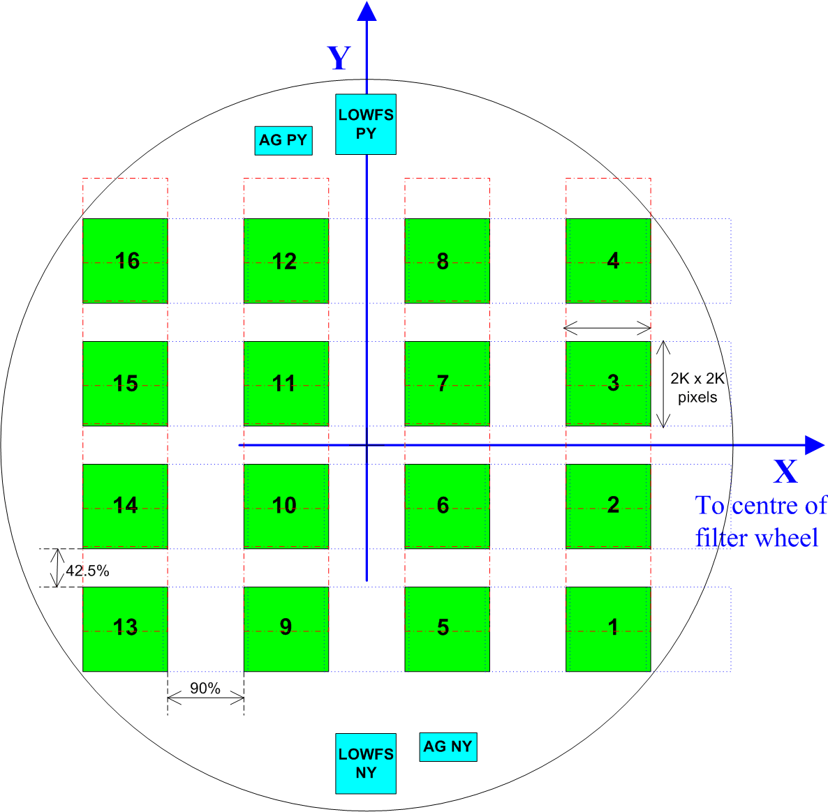
Figure 2-1: Layout of the 16 science detectors in the focal plane. Circle is 1.65 deg in diameter. Also shows “effective locations” (via pickoff mirrors) seen by the autoguiders (AG) and the LOWFSs.
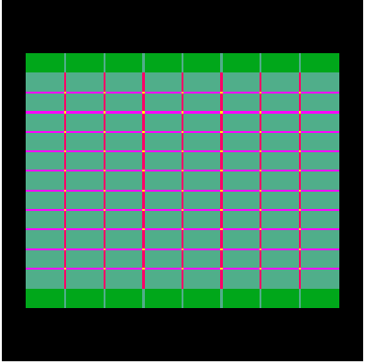
Figure 2-2: Exposure time map for a filled tile of 6 pawprints (no jittering). Dark green = 1, light green = 2, magenta = 3, red = 4, yellow = 6, in units of the single-pawprint exposure time.

Observing Considerations
The hardware clearly places certain constraints on operational modes, though not many, as the system has been designed to be fairly flexible. Since there is only one moving part in the camera (the filter wheel), the telescope and instrument configuration is primarily specified by the pointing direction (RA and Dec), the Cass rotator angle and the filter.

The Cass rotator has a travel of 540 degrees so the position angle of the focal plane with respect to the sky may be chosen freely (the default will probably be the long (X) axis aligned East-West). Note that the focal plane assembly, autoguiders and LOWFSs are 180-deg symmetric, so if desired one can observe a field at two camera angles 180° apart while re-using the same guide stars.

The most obvious constraint is the layout of detectors on a 4 × 4 rectangular grid with gaps of 90% of a detector width in x and 42.5% in y. This requires observing 6 “pawprints” to give a filled “tile”. Each pawprint may comprise many exposures at different jitter or microstep positions, as desired for optimal flat-fielding and/or sampling. These moves are user-selectable and not “quantized”, but should be limited in size. This is because after tiling moves, the overlaps between adjacent pawprints have a width of ~ 5% of a detector or 30 arcsec. Therefore jitter moves within a pawprint must not exceed ± 15 arcsec away from a “central” jitter position to avoid underexposed stripes in the final tile. Figure 2-2 shows an exposure time map for a filled tile that is composed of six pawprints.

Due to field distortion, if we want to use microstepping, the constraint is more stringent. The radial plate scale in arcsec/pixel is 2.4% larger at the field corner than the centre, so e.g. a microstep of 9.9 pixels at the centre corresponds to 10.14 pixels at the field corner. Therefore, microstep offsets must be limited to not more than ~3 arcsec.

Ultimately if one wants both microstepping and a jitter size ≥ 3 arcsec, separate nested loops are required. This is fine for deep exposures but may preclude microstepping for shallow surveys.

Active Optics and Guiding
The VISTA active optics system is largely “transparent” to science observing. There is a closed-loop low-order wavefront sensing system (controlling focus and collimation of M2), and an open-loop (lookup table) high-order system controlling the figure of M1 via 84 axial force actuators.

There are two identical fixed autoguider and LOWFS units at opposite sides of the FOV, each fed by a pickoff mirror and a fixed filter (roughly I-band). Each autoguider has one frame-transfer CCD chip giving an 8 × 4 arcmin field, although only one will be in use at a time (whichever has a brighter star).

The LOWFSs have large enough field of view (8 × 8 arcmin) to contain a usable star for almost all telescope pointings, so should not impose significant pointing constraints, and they usually add no “overhead” since their exposures should start after and finish before the science integrations. Use of the LOWFSs imposes a minimum time between jitter moves of ~30sec since they have to complete an exposure with adequate SNR in between consecutive jitter moves. If it is essential to jitter more often than once per 30 sec, this can be done using open-loop M2 control, though a slight loss of image quality may result.

The one exception is after a telescope slew giving a large (≥ 10°) change in altitude. Then there may be a need for a 30-sec pause for one LOWFS cycle to complete and update the M2 position before science observing re-starts.

Given the above sensor fields, generally a “jitter” movement of ≤ 15 arcsec will re-use the same guide and wavefront sensor stars by simply offsetting the selected readout window in software, whereas a “tiling” offset of 5-10 arcmin will almost always require different guide and LOWFS stars to be selected after the move. Checking and acquiring the new guide star will impose a short overhead of ~1 second per tiling move.

Filters
The filter exchange mechanism is a large wheel of 1.37m diameter (actually an annulus with a fixed pillar through the centre) with 8 main positions for 1 dark and 7 science filters. Filter exchange time is expected to be ~ 15-45 sec depending on angle. This is clearly longer than that for a jitter or tiling telescope move, so it is generally more efficient (and gives better sky subtraction) to complete a tile in one filter, then change filters and repeat.

Filters will be ordered in the wheel so that the detectors do not see an increased background during filter change. Due to non-uniform temperature across the wheel, a filter change is likely to cause a small warming of the detectors, but this should be corrected by the temperature servo system, so the temperature rise should be ≤ 0.1K for a few minutes after the change. With a wheel temperature < 110K, photon emission from the wheel itself should always be negligible.

The wheel also contains “mini-filters” in the V-shaped sectors in between the large science filters. These mini-filters cover only a small fraction of the focal plane, and are primarily for engineering use.

Survey Efficiency

Introduction
VISTA’s overriding purpose is to conduct surveys efficiently, and therefore observing templates must be designed to maximise speed, but without compromising the scientific integrity of the data. [RD6] discussed the observing efficiency budget for system design purposes. To aid in determining efficiency of observing strategies and of observing templates, this subsection indicates the typical expected overheads in the operation of the VISTA/VIRCAM in terms of the time needed for each change of state/movement of the system between exposures. Of course the effect of these overheads on survey efficiency is particularly strong for surveys involving short exposures.

Moving to a new Tile
The time to go to a new tile will depend on how far away it is in altitude and azimuth from the current position, and on the zenith distance. As for any alt-azimuth telescope at VISTA’s latitude one wants to minimise presets between objects with Dec < -24° to Dec > -24° and vice versa. Both alt and azimuth can accelerate at 0.5º/s² and max angular velocity is 2°/s, so it takes a 4-sec ramp-up to reach max angular velocity (and covers 4 deg in those 4 sec). The Cassegrain rotator is faster (1°/s² and 3.6°/s) so will hardly ever be the limiting overhead.

The “worst case” preset is a 270° azimuth move from SE to NE which has to go the long way round via W due to the cable wrap, and which will take ~140 seconds. These situations should be avoided, if at all possible, during scheduling.

A small preset of 2º on-sky, in the worst case, can require a ~ 60° azimuth move if alt = 88°. Fortunately a more “typical” case at alt = 60° only requires a ~ 4° azimuth move. Assuming an acceleration of 0.5°/s² for 2.82 sec followed by equal and opposite deceleration at same rate, this will take ~ 5.84 seconds (a smoother algorithm may take a bit longer so ~10 sec is a more reasonable estimate). If the 2° is mostly in Altitude it will be somewhat quicker.

In the best case the time to go to a new tile will be comparable to that to change to an adjacent filter or to offset, but in general it will be longer.

Changing Filter
Sec 4.3.3.2 of [RD4] specifies the filter exchange time for an adjacent filter as <25sec although the expected time is ~12 sec. The filter exchange time to any filter is specified as <60sec and the expected time is ~40 sec.

Moving to a new Pawprint, Jitter, Microstep
- The time to offset to another pawprint of the same tile (5-10΄) will be ~10sec.
- The typical time to move a jitter step (<30˝) within a pawprint will be ~4sec.
- The typical time to move a microstep (<3˝) within a jitter will be ~2sec.

Although the LOWFS operates in parallel with science observations up to 30sec integration is required for adequate S/N in the 99% faint case. In all cases, including the brighter cases, averaging over several LOWFS exposures will be needed because the atmospheric errors (which are independent of star brightness) go as 1/√(Time). Care will need to be taken to minimise overheads associated with LOWFS, especially if exposures are short, or if LOWFS would start at the end of science integrations.

Exposures
The minimum single integration time is equal to the readout time of approximately 1s. The way the exposure time is made up of integrations may be filter and sky brightness dependent, for example the time for sky to half-fill the wells is ~8-12s (H and K_{s}), longer for other filters. The minimum sustainable duty cycle for exposures is 10 seconds. The overhead for one exposure of N co-added integrations is expected to be (N+1) × (readout time) seconds, e.g. a typical 60s exposure comprising 6 co-added integrations will take approximately 67s elapsed time. How this translates into designing efficient survey practice, trading off instrument and telescope overheads against sky condition and science aims, is beyond the remit of this document.

Summary of Science Requirements

Introduction
The following specific requirements, whilst placed on the end-to-end VISTA system, indicate the accuracies expected from the calibration pipeline. These have been outlined in detail in the VISTA Science Requirements Document (SRD) [RD3]. In what follows we append a specific reference to the section of the SRD from which the requirement is drawn.

Astrometric Accuracy
- [from SRD 4.5.1/1] For sources bright enough so that there is negligible centroiding error due to photon noise, the end-to-end system shall deliver differential astrometric accuracy of 0.1′′ RMS over the whole of the field covered by the IR mosaic to an airmass of 2.
- [from SRD 4.5.1/2 and 4.5.1/4] For sources bright enough so that there is negligible centroiding error due to photon noise, the end-to-end system shall deliver differential astrometric accuracy of ≤ 0.03′′ within the field covered by each individual IR detector to an airmass of 2.
- [from SRD 4.5.1/3] For sources bright enough so that there is negligible centroiding error due to photon noise, the end-to-end system shall deliver absolute astrometric accuracy of ≤ 0.3′′ over the whole of the field covered by the IR mosaic to an airmass of 2.

Photometric Accuracy

It is assumed that a well defined grid of standard stars will be available on the southern sky.

- [from SRD 4.6.1/1] The end-to-end system should not preclude achieving absolute photometric accuracies (in J, H and K_{s}) of 0.02^{m} (with a goal of 0.01^{m}) on sources bright enough so there is negligible photometric error due to photon noise, over the survey region.

Non operational Detectors
- The pipeline shall be capable of operating normally if a subset of the detectors is missing or non-functional.

Data-Flow System Requirements

Basic Operation

VISTA will adhere to a limited but flexible set of observing templates, designed to use the instrument to its maximum efficiency and to enable calibration. Unlike other ground-based telescopes, where a few nights at a time are allocated via a competitive process to conduct one-off experiments, at least 75% of VISTA’s time will be dedicated to coherent long-term surveys.

O

stability of flatsv

The observing system will be capable of performing overlapped observations suitable for the construction of filled-in tiles, although such further image combination is beyond the scope of the pipeline.

Pipeline Requirements

Outline
Broadly speaking there are four separate pipeline requirements:
- Removal of Instrumental Signature
- Astrometric Calibration
- Photometric Calibration
- Measuring Data Quality

Instrumental Signature Removal
The aim of instrumental signature removal is to produce, as near as possible, an image as though it were taken with a perfect, linear, blemish-free camera. The images arrive from the DAS having already been reset-corrected. Thereafter the data flow system is responsible for providing the following operations:

- Dark Correction: This is needed to subtract out the thermal dark current and the reset anomaly from each frame.
- Linearisation: Detector outputs (including amplifier and ADC) are generally non-linear. This operation has to reduce the non-linearity to acceptable levels, taking into account the complexity involved in the readout process. This effect requires specific characterisation and long-term monitoring.
- Gain Correction: This is required to remove the following multiplicative effects:
  - pixel-to-pixel quantum efficiency variations
  - large scale variations, mostly due to vignetting
  - global gain variations between detectors
Observations of a uniformly illuminated far-field are used to model these effects. The resulting ‘flat-field’ is used to normalise the target observations.
- Background Correction: The sky in the infrared is variable both temporally and spatially over short intervals. Some broad passbands also have contributions from sky fringing and thermal emission from dust on the camera optics. Background correction is required to reduce these effects to acceptable levels.
- Electrical Crosstalk: Each of the 16 VIRGO detectors will be read out using 16 adjacent channels. The signal from one channel can interfere with the signal on other channels or detectors that are clocked out at the same time. The crosstalk may be negligible, but needs to be specifically characterised prior to, or during, commissioning and monitored thereafter. The effect will be characterised and removed via a crosstalk matrix of 256x256 entries.
- Persistence: Images of objects from previous exposures may remain on a detector for some time after the initial image was taken and possibly spread into adjacent pixels. The rate of decay of such images and their possible adjacency effects require characterising during commissioning and monitoring thereafter. Persistency effects, if present, then need to be reduced as much as possible in science frames.
- Non-uniform illumination: Although the flat field normalisation described previously should take out all of the large scale variation in sensitivity, in practice this may not be so. As with any camera, VIRCAM may have scattered light present. This will impose a smoothly varying structure on the otherwise uniform flat-field illumination and hence will result in a variation in the photometric zeropoint across the detector. This requires characterising and mapping to a suitable level of accuracy.
- Bad pixels: Bad pixels (including hot pixels) are to be flagged from the beginning of the pipeline processing using confidence maps. When the exposures from a jitter sequence are combined into a single image, the effect of bad pixels must be reduced to minimal level.
- Under-sampling: In times of exceptional seeing, the point-spread function will be under-sampled. If this occurs, then observations that are microstepped for interleaving may be required. This involves taking a group of four exposures, each of which is offset by an integer number of pixels, plus 0.5. The pipeline should then interleave the four exposures into one frame with twice the pixel resolution, thereby recovering some of the lost spatial resolution.

Astrometric Calibration
Routine astrometry of VISTA science data is required for all science data. Any astrophysical exploitation of the data depends on being able to locate sources precisely (in particular for follow-up observations) and to register multi-wavelength images and maps. The astrometric calibration will be manifested in the form of a FITS-standard World Coordinate System (WCS), in the International Coordinate Reference System (ICRS).

The observing system will write an initial WCS derived from knowledge of the focal plane and camera geometry, as well as the pointing information provided by the TCS. The accuracy of the initial WCS is required to be ≤ 5˝, but is expected to be ≤ 2˝ [RD3]. During pipeline processing, a precise WCS must be derived for the output frame (which in general will be a combined image) by referring detected point-sources to the 2MASS or USNOB catalogues. The accuracy of the precise WCS is required to be ≤ 0.2˝, but is expected to be ≤ 0.1˝.

Photometric Calibration
In order to fulfil the science requirements, sufficient photometric standards must be observed each night to enable the pipeline to produce photometric zero points and extinction measures. Non-photometric nights will be flagged via error estimates in this calibration.

The manifestation of the photometric calibration in output data frames must be recorded in the FITS header records that describe the transformation between internal (instrumental) fluxes to magnitudes on the VISTA photometric system. It is assumed that a suitable catalogue of standards will exist, which may have to be generated in a special observing programme. Some secondary standard fields for VISTA will be defined as part of the observing programme for WFCAM (but this does not imply that VISTA is dependent on WFCAM operations).

Data Quality
Data quality measures must be made and recorded at all stages of the reduction procedure including, but not limited to, QC-1. This includes comparing calibration frames with master frames and looking for spatial and temporal variations. Science data must be examined for uniformity of overlap areas, consistency of PSF across detectors and numbers of ‘negative’ in addition to ‘positive’ spurious images. The offset from initial to final WCS provides a measure of the telescope acquisition performance, whereas trailed or distorted PSFs can be an indication of poor tracking or other problems. Variations in the photometric zero point and/or extinction coefficient can be used to flag poor observing conditions.

A more comprehensive list of data quality indexes to be used is described in the Data-Reduction Specifications document [RD2].

Survey Planning

Introduction
Unlike most other ground based telescopes, where a few nights at a time are allocated via a competitive process to conduct one off experiments, at least 75% of VISTA’s time will be dedicated to a set of coherent long term surveys and most of the remaining 25% will be used for Principal Investigator-led surveys. A typical multiband survey would cover a certain area (which may or may not be contiguous), would be observed to a uniform depth in several filters and would possibly be done with some repetition to pick up variability. Such a survey will normally be the result of the combination of many observations made over many nights and several such surveys will probably be running concurrently.

A typical survey consists of a number of filled tiles and involves observing: F filters * T tiles * P pawprint positions/tile * J jitter positions/pawprint * M microstep positions/jitter * E exposures/microstep. This produces a total of F*T*P*J*M*E raw exposures to be saved in the archive.

There are 4 filters delivered with VISTA so initially F can be 1 to 4. If further filters become available, F can be up to 7. In any situation where darks may need to be taken interleaved with sky exposures (for example if there are problems with unstable reset anomaly) the cold blocker can be considered another filter. The number of tiles, T, in a survey will depend on the areas to be covered and the coverage strategy. The default method of making a tile requires P=6. J=1 means no jittering and M=1 means no microstepping. E = 1 usually (i.e. all the required exposure time is taken in one exposure). But one might want to divide the required exposure time into several sub- exposures (e.g. to check for time-dependence of sky), so E could be > 1.

The DFS is not expected to produce complete calibrated surveys, but to calibrate the data from each night. The unit of sky area that the DFS will calibrate is a pawprint in a single filter observed in a contiguous block of time. It is recognised that in general the pawprint will be a component of a tile, that complementary pawprints may exist in other filters and that the pawprint may have been observed multiple times on the same or different nights for stacking or variability. It is not within the remit of the DFS to combine the pawprints. However the calibration of the individual pawprints should be carried out with a view to providing the necessary calibration information to enable such combinations to be made by others.

Survey Scheduling
These surveys are large multi-night (or multi-year) programmes and the scheme by which the component observations are best scheduled will need to take account of this. It may be that the current Paranal observing queue scheduler imposes undesirable restrictions on the scheduling of VISTA’s surveys. Such questions, and potential solutions to any problems identified, are outside the remit of the VISTA Data Flow System deliverables to ESO, but will be investigated by a small (VISTA) Survey Scheduling group with a suitably experienced individual at its core. It is planned that the Phase A design study of the survey-scheduling group will have been completed and agreed with ESO in good time for the FDR documentation of the VDFS. The present document is restricted to considering how best to make observations scheduled for any given night, regardless of how they were derived.

Nesting of Component Observation Loops of a Survey
The component observations of a survey (filters F, tiles T, pawprints P, jitters J, microsteps M, and exposures E) can in principle be nested in various orders, subject to some restrictions, such as the innermost loop always being E. Different nestings require different observing templates, and it is necessary to chose a suitable subset of the possible nestings, without precluding the later addition of other templates should a use for them be identified. Thus the observing templates are classified and described in the Calibration plan [RD1] in terms of the nesting of the component loops.

Although it is not strictly necessary to complete all pawprints of a tile before moving to the next tile it will generally be efficient to do so, thus it is assumed that a pawprint, P, is always nested within a tile, T, since a tile is always composed of a set of pawprints. Survey nestings whose innermost loops are not JME are assumed, on grounds of efficiency, not to be needed at present.

Using a shorthand (based on the order of nesting of the loops for the 6 components F,T,P,J,M,E with the order of the letters indicating increasing nesting of the loop as one reads to the right) the three remaining nestings would be:

- FTPJME — Complete all tiles in one filter, change filters and repeat the tile sequence. The observation loops would look something like this (where Check/Set means check if the system is already in the demanded state, or position, and if it is not change state, or move position):

For each demanded filter position (1 to F)
For each tile ‘centre’ position (1 to T)
Preset to tile ‘centre’ position
Check/Set IMAGING mode
Check/Set camera PA in parallel [default +X axis to +RA]
Check/Set demanded filter in parallel
For each pawprint (steps 5-10΄) (1 to P)
Check/Offset telescope to pawprint central position
Acquire guide star
LOWFS on two stars in parallel (for minimum of 30s)
For each jitter-position (1 to J)
Move telescope (steps <30˝, same guide star)
For each microstep (1 to M)
Move telescope (steps <3˝, same guide star)
For each exposure (1 to E)
Make exposure
Next exposure
Next microstep
Next jitter
Next pawprint
Next tile
Next filter

- TFPJME — Complete each tile in all filters before starting on the next tile in the sequence. This would have the following observation loops:

For each tile ‘centre’ position (1 to T)
Preset to tile ‘centre’ position
Check/Set IMAGING mode
Check/Set camera PA in parallel [default +X axis to +RA]
Check/Set first filter in parallel
For each demanded filter position (1 to F)
Check/Set demanded filter in
For each pawprint (steps 5-10΄) (1 to P)
Check/Offset telescope to pawprint central position
Acquire guide star
LOWFS on two stars in parallel (for minimum of 30s)
For each jitter-position (1 to J)
Move telescope (steps <30˝, same guide star)
For each microstep (1 to M)
Move telescope (steps <3˝, same guide star)
For each exposure (1 to E)
Make exposure
Next exposure
Next microstep
Next jitter
Next pawprint
Next filter
Next Tile

- TPFJME — Complete each pawprint of the tile in all filters before starting on the next pawprint of the tile. This would have the following observation loops:

For each tile ‘centre’ position (1 to T)
Preset to tile ‘centre’ position
Check/Set IMAGING mode
Check/Set camera PA in parallel [default +X axis to +RA]
Check/Set first filter in parallel
For each pawprint (steps 5-10’) (1 to P)
Check/Offset telescope to pawprint central position
Acquire guide star
LOWFS on two stars in parallel (for minimum of 30s)
For each demanded filter position (1 to F)
Check/Set demanded filter in
For each jitter-position (1 to J)
Move telescope (steps <30˝, same guide star)
For each microstep (1 to M)
Move telescope (steps <3˝, same guide star)
For each exposure (1 to E)
Make exposure
Next exposure
Next microstep
Next jitter
Next filter
Next pawprint
Next Tile

Each of these three alternatives would produce the same number of output files, but the observing overheads would not be the same, and in variable atmospheric conditions the relative limiting magnitudes achieved in each filter would be different. Furthermore the time baseline over which colours were calculated would be different.

(There are further possible alternatives if we allow the filter F to change within the J or M loops, or relax the restriction that JM loops be within P loops, or that M loops be within J loops, or that ME must be in the inner loop.) Another example where the sequences would be different is a wide shallow survey compared to a narrow deep survey.

This illustrates the fact that surveys with different aims may want to use different observing sequences, as well as exposure times, and that there may be tensions between a sequence that is preferred and another that is more efficient. The ETC tool will provide the time for each allowed observing sequence input to be computed and a quantitative comparison made.

Observing templates
The DFS pipeline deals with calibrating nights of data, not producing whole surveys, whilst recognising that the nights form part of whole surveys. Therefore the templates that are defined in the Calibration Plan [RD1] are those that are appropriate for observing single pawprints, or for observing the pawprints necessary to complete a tile during a single night.

At PDR templates are defined in the Calibration Plan [RD1] only for those observing sequences that are perceived as most likely to be used, not for every template that is possible. However, it is important that the observing templates allow the necessary flexibility in designing surveys to enable each of the Design Reference Surveys given in [RD5] to be carried out, together with, any further Design Reference Surveys that may be identified before FDR.

__oOo__

