Telescope Calibration Meeting - 11 February 2004
A meeting was held at the UK ATC on 11 February 2004 on the topic of telescope calibration. This document, based on Powerpoint slides presented at the meeting, summarises the discussions and the conclusions.

Present:
- Steven Beard ATC, IR Camera
- Nirmal Bissonauth Durham, Wavefront sensing
- Andy Born
- Alastair Borrowman
- Simon Craig
- Gavin Dalton
- Richard Myers Durham, Wavefront sensing
- Malcolm Stewart
- Will Sutherland

Goals
  - Identify the calibration data that need to be measured to allow the telescope to meet its requirements.

  - Identify the procedures necessary to measure these data and estimate the frequency with which these procedures will need to be performed.

  - Identify the equipment needed for each procedure, including Camera subsystems (guiders, WFSs), Test Camera etc.

  - Identify software, e.g. scripts, to make these procedures viable or more efficient.

  - Confirm operations software has the necessary functionality.

  - Identify necessary/useful analysis software, specially written or off the shelf.

  - Provide input to:
- VPO Systems:
  - Telescope Commissioning Plan
  - Telescope Calibration Plan
  - Test Camera Requirements
- VPO Software
  - Maintenance and Verification Software (scripts)
  - Confirmation that runtime software (C and C++) has necessary features
- VPO Hardware Work Package Managers
  - Anything that affects contracts

Scope
- Included:
  - Telescope hardware
  - Guiders and WFSs (Camera hardware)
  - Telescope software: TCS and subsystems
  - Calibration hardware

- Excluded (but can be discussed)
  - IR Camera (except as above)

Calibration main topic of meeting but we can also consider related performance measurements

Types of Calibrations
Calibrations will be performed in the phases:
- Commissioning Phase
  - Can be relatively ad hoc
  - Can use “disposable” test gear

- Operations Phase
  - Periodic Calibrations
  - Calibrations After Engineering Work
  - Need documentation and better software support

The following systems were identified as needing to be calibrated:
- Axes – altitude, azimuth and rotator
- Location of rotator axis
- Telescope pointing
- M1
- M2
- Guider
- Wavefront sensors
- Active optics software

Telescope Axes
The following data will need to be derived:
- Servo parameters
- Encoder calibrations
- Locations of limit switches

These are all covered by standard procedures. VISTA does not have any calibration requirements that are different, except in detail, to other ESO telescopes at Paranal.

Pointing

Introduction
The following need to be done:
- Define reference point
- Decide pointing model
- Acquire pointing data
- Analyse pointing data
- Update pointing coefficients

Pointing on the VLT
  - Rotator axis is fundamental (but VISTA can’t see it)
  - Observations always made with guide star
  - Stored WCS data derived from guide star’s co-ordinates
  - Blind pointing needs only to be good enough to lock onto correct guide star efficiently
  - Pointing model and analysis software based on tpoint
  - Automatic procedures exist
  - Nightly 3-star pointing tests not done
  - Pointing tests done infrequently
  - Pointing test is scheduled when logged errors get too large
  - VISTA’s blind pointing should be better than VLT’s

No On-Axis Detector
VISTA’s focal plane is as shown below. The relevant features are:

- There is no detector at the centre of the focal plane and so the point on the sky corresponding to the Rotator axis cannot be observed.

- There are two autoguider CCDs diametrically positioed at the edge of the field.
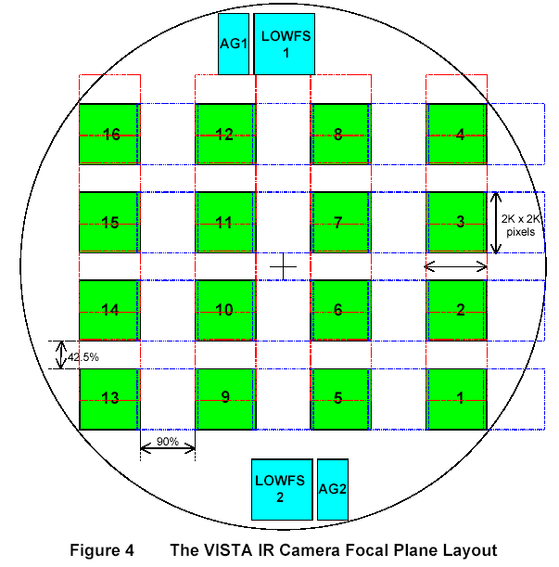

On the VLT, the (α, δ) pointing origin is the point on sky coincident with Rotator axis. Pointing tests are performed by centring up a star on the guider positioned at Rotator axis

On VISTA, the (α, δ) pointing origin will also be the point on sky coincident with Rotator axis. However pointing tests must be performed using a star positioned off-axis on either a science detector or a guider detector. (A WFS detector could also be used but this has no advantages).

The relative advantages of these two types of detector are:

Guide CCD:
- Controlled by TCS, similarly to the VLT, and so existing software and procedures can be reused.
- Can be read out quickly, so procedure is more efficient and other tests such as tracking can use the same star and hardware

Science detector:
- Not so far off-axis
- Errors in mapping science detectors to pointing origin vanish (but focal plane still needs to be mapped and anyway these errors do not affect the astrometry).

The clear conclusion form the discussion was that a guide CCD should be used for pointing.

Procedure
- For each sample in the pointing test select
      - guide star with coordinates (α, δ)
      - set rotator to constant celestial PA (0°, say)
      - calculate corresponding (α’, δ’) of telescope axis (i.e. Rotator axis)
      - centre star and record telescope position
- Analyse data comprising the set of (α’, δ’)

Note that we need to know relative positions of guider and rotator axis (but need this anyway)

Pointing Performance
- Each time a guide star is acquired:
  - centre it on Guider
  - log distance it had to be moved: pointing error

- Analyse pointing errors as f(t). When these are judged excessive, a pointing test is scheduled.

- This is “standard” VLT procedure

Location of Rotator Axis
Because VISTA cannot observe the point in the sky corresponding to the Rotator axis, a potential problem exists in locating it accurately. The presence of two diametrically opposed guide CCDs helps.

Because the WCS information stored in the FITS headers is effectively derived from the guide star’s co-ordinates, locating the Rotator axis relative to the guiders is more relevant that relative to the science detectors. (Mapping the science detectors relative each other and to the guiders will be an IR Camera calibration procedure. Final astrometry will be derived from the science data, not the FITS headers.)

The procedure will be:
- Track open loop well away from zenith
- Choose two stars separated by guider separation
- Point axis at mid point and measure stars’ positions on guiders
- Rotate 180° and measure new positions
- Correlated difference gives axis error
- Repeat n times to remove effect of tracking error
- Repeat in other axis (α or δ)

Note 1: Needs concurrent operation of two guiders.
Note 2: Additional software may make the procedure easier to perform but is not necessary.

Tilt of Camera wrt Rotator
The tilt of the camera focal plane wrt the Rotator cannot be completely corrected by wavefront sensing and optical realignment. This tilt can be determined by measuring the focus across the focal plane at different rotational positions of the camera, first the Test Camera (assuming it has off-axis sensing) and then the IR Camera. It can be corrected by physical adjustments during commissioning.

Tracking Performance

Alt/Az
Measuring the performance of alt/az tracking can be done by logging time-stamped centroids from a guider. This can be used both open and closed loop.

Rotator
Either
- Put a star on each guider
- Log time-stamped centroids from both guiders
- Correlated motion is alt/az tracking error
- Anti-correlated motion is rotator tracking error
Or
- Close alt/az tracking loop on one guider
- Log time-stamped centroid from other guider
- Motion is due to rotator tracking error

The former is probably preferable since it allows open loop tracking performance to be measured concurrently on all three axes.

This depends on being able to operate the two guiders concurrently. This is not a formal requirement on that system, but the design provides it. Concurrent operation (measuring and logging, but not loop closing) should now be considered a requirement.

M1 Control
The following data will need to be provided:
- Actuator Volts to Newtons transfer function
- Servo coefficients within actuator hardware
- Servo coefficients for axial force balancing
- Servo coefficients for lateral force closure
- Matrix to offload force from a disabled actuator
- Force limits

These do not require any calibration procedures at the telescope.

The transformation from wavefront modes to forces is done within the active optics software.

M2 Control
Data such as control servo coefficients and operating limits will need to be provided, but these will not require any procedures at the telescope.

The relationship between Zernike coefficients and M2 positions will be calculated.

Wavefront Sensors
The following data will be required by the wavefront sensors:
- Null aberrations
- CCD geometry: scale, position, rotation, size
- CCD window sizes
- sanity check parameters
- magnitude limits for guide and aO stars
- CCD set-up parameters

These will not require any special procedures at the telescope. The null aberrations will be calculated, e.g. from Zeemax.

Active Optics
The following data will be required:

Null aberration parameters
These will be calculated, e.g. from Zeemax.

Optical distortion parameters
These will be calculated, e.g. from Zeemax.

Open loop M2 Zernikes as f(elevation, T)
Wavefront tilt due to the effect of elevation on M2 can be measured during commissioning by using an auto-collimator mounted at Cass looking at the flat on M2. These measurements can then be refined by using the wavefront sensors in the Test Camera and the IR Camera. Data can be analysed off-line, e.g. using existing VLT software (see M1 below). The temperature coefficients will be calculated.

Open loop M1 modes as f(elevation, T)
These will be obtained similarly to the M2 Zernikes, except the high order WFS will be used. Although harmonics rather than polynomials would be expected to provide a better fit, ESO’s experience on the VLT is that Legendre polynomials work better. VISTA will therefore also use polynomials, allowing reuse of off-line analysis software used on the VLT. Initial values of the coefficients can be calculated (probably quite accurately). During the calibration process, the M2 loop should be closed.

To check that aberrations within the Camera and alignment of the Camera focal plane wrt the Rotator plane are not a problem, measurements can be made at different Rotator angles, e.g. every 90°.

M1 Modes to Forces
A conversion matrix is needed to convert wavefront modes into force vectors. Initial values can be calculated. These can be refined by applying known force distributions and measuring the resultant wavefront, analysing the results off-line. VLT software can probably be reused for this.

