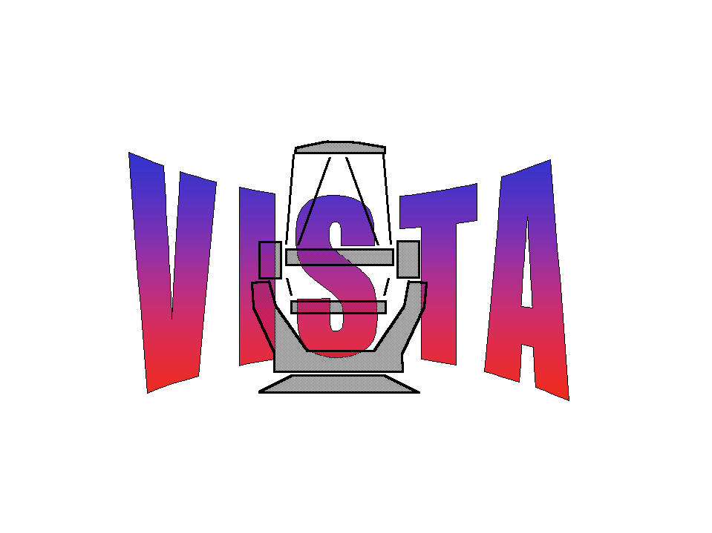

Document Number: WFC-CAS-WPS-00000-00018
Document Title: End of Month Report Aug 04
Document Authors: Mike Irwin, Simon Hodgkin
Document Issue: 1
Document Date: 1/09/2004

Summary

This document presents workpackage progress by CASU during August 2004.

For further details of group activities over the past month and quarter see

http://www.ast.cam.ac.uk/vdfs/diary.html

For the minutes of all group meetings see

http://www.ast.cam.ac.uk/vdfs/docs/minutes

Highlights

- UKURD for VDFS is imminently about to be released after much iteration and discussion. In a nutshell the VDFS UKURD represents a modest series of enhancements on the WFCAM pipeline capabilities. After the URD is agreed we need to assess how much more development work will be needed to fulfil the extra requirements.

- APM refurbishment continues almost on schedule (miracle!). Much of the movement of equipment and personnel is either completed or in advance stages of organising. Building will be completely vacated (and emptied) by late September. The APM will make its final journey at this time. With installation of portable cooling unit (probably) all processing and storage hardware will (probably) be online again in MJI's new sweatshop after slight ~1-2 day hiatus during the 4 racks of kit disassembly, move and reassembly.

- The DIC was submitted at the start of the month according to plan and represents a good chunk of the v0.5 document agreed for FDR.

- The IPHAS Galactic Plane survey continues to be an excellent test bed for various aspects of operational pipeline development and process monitoring. In lieu of WFCAM data we have been running this using a similar operational model, to test out some aspects of routine pipeline operations.

- PSF determination and estimation (stages 1,2) are proceeding well. We now have alternative schemes in hand for PSF generation that give us a range of options to deal with real WFCAM data.

- It now looks like several aspects of on-sky characterisation will be possible in the autumn commissioning. The new schedule is also much better aligned with the needs of CASU and WFAU to thoroughly shakedown the end-to-end system before routine WFCAM observing begins in earnest.

Concerns

- Unable to make much progress on the ESO VDFS docs WPs 2.1,2.2,2.3 due to lack of final version of RIX response document.

- Our inability to read LTO-I tapes written on WFCAM-like LTO-I drives at reasonable speed is causing concern in some quarters. The most likely problem is a hardware (firmware) problem in their Seagate drives (but then we would say that).

Matters Arising

- What is the status of the RIX responses? Before we can commit more changes to the ESO docs we need to see the final version of this document signed off by all parties.

- We are keen to hold a meeting with JMS and SB in the near future to discuss the detail of some of the changes required in the ESO docs. We hope to have a face-to-face meeting or telecon to discuss changes to the ESO PDR docs by mid-September; and then plan to produce complete draft versions of all the FDR docs by mid-October in plenty of time for iteration prior to submitting the docs to ESO by mid-November.

