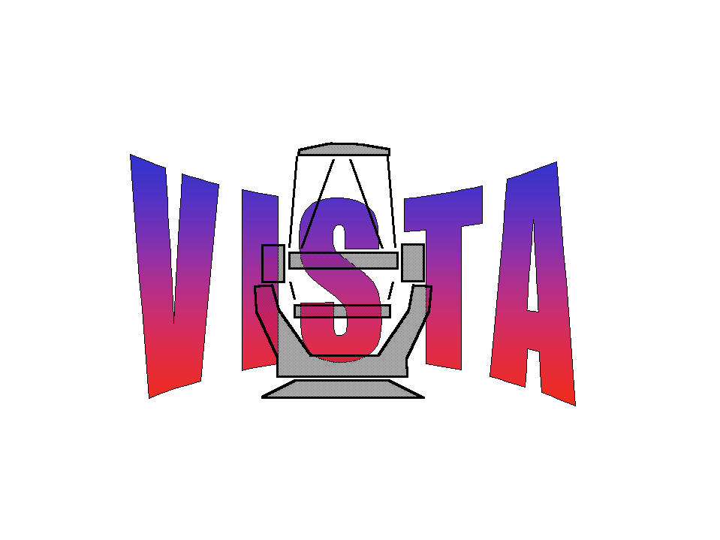

Document Number: WFC-CAS-WPS-00000-00001
Document Title: End of Month Report Apr 2003
Document Authors: Simon Hodgkin, Mike Irwin
Document Issue: 1
Document Date: 9/5/2003

Summary

This document presents workpackage progress by CASU during April 2003

For further details of group activities over the past month see

http://www.ast.cam.ac.uk/~wfcam/diary.html

For the minutes of all group meetings see

http://www.ast.cam.ac.uk/~wfcam/docs/minutes

Positives:
- fortnightly meetings in place and working well. Helping group focus and peer pressure
- system documentation via WWW pages
- management documentation and infrastructure in place
- JAC summit hardware review - hardware and transfer media (Ultrium tapes) agreed with CASU
- good progress on ESO documentation
- critical workpackages proceeding as planned

Concerns:
- grant not finalised
- management overheads currently larger than anticipated
- WFCAM exposure time halved – data volume doubled
- tight schedule for ESO PDR documentation delivery

