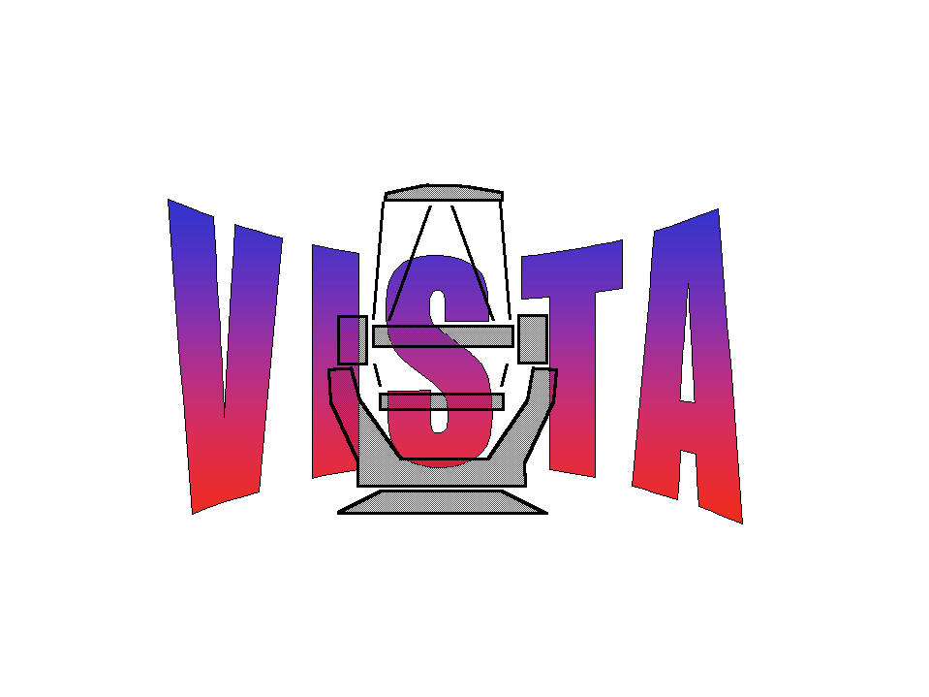

Document Number: WFC-CAS-WPS-00000-00003
Document Title: End of Quarter Report Q2 2003
Document Authors: Mike Irwin, Simon Hodgkin
Document Issue: 1
Document Date: 2/7/2003

Summary

This document presents workpackage progress by CASU during June 2003 and is a summary of progress throughout Q2 2003

For further details of group activities over the past month and quarter see

http://www.ast.cam.ac.uk/~wfcam/diary.html

For the minutes of all group meetings see

http://www.ast.cam.ac.uk/~wfcam/docs/minutes

Positives:

- Although the ICDs and FITS header specification documents between CASU, JAC, ATC and WFAU are not signed off agreement on the outstanding issues has been reached
- Agreement on observing protocols and design of the MSB support infrastructure
- INT WFC pipeline infrastructure and pipeline progress database and monitoring tools are proving to be a good template for WFCAM
- Good progress on interfacing trial pipelines within ORAC-DR
- Good progress on standard pipeline implementation and documentation
- Good progress on photometric standards and calibration WP
- Good progress on co-located list driven photometry WP
- Good progress on stacking and mosaicing WP
- Difference imaging WP proceeding better than expected
- 2MASS catalogues have been installed and successfully used in trial calibrations

Concerns:

- Responding to and dealing with non-WP management requests has been disruptive (eg. VEGA bid)
- Management overheads were seriously underestimated
- Lack of direct liaison with VISTA camera IR team
- Out of date VISTA SRD and OCDD documents

- Lack of UK VISTA requirements on pipeline products and science archive deliverables
- Lack of realistic engineering data for tests delays development of optimum processing strategy

- Slow progress in simulations and testing standard catalogue products

- Slow progress on interpolation techniques and PSF modelling WP

